**Application Pack**

**Communications Manager**

**Closing date for applications: 22nd April 2025**

**Alexander Devine Children’s Hospice Service**

Alexander Devine Children’s Hospice Service (Alexander Devine) is a local charity that provides specialist care and vital support to babies, children and young people with life-limiting and life-threatening conditions, and their families, across Berkshire and into surrounding counties.

We individualise our approach to meet the unique clinical, emotional and practical needs of each child and their family, ensuring they receive the best possible care and support. Our comprehensive range of care services include Respite care, Specialist play, Symptom management, Family support, End of life care and Bereavement support. We provide care from our children’s hospice in Maidenhead as well as in the family home and across the community, including hospitals and schools.

Our hospice facilities offer opportunities for children and their siblings to experience fun, joy and adventures, and help families make precious memories for as long as they have. These include a hydrotherapy pool, sensory room, music room, games room, outdoor playground and sensory garden, six children’s bedrooms and two self-contained family flats. We also have a dedicated bereavement suite with its own garden.

Our children’s hospice service is free of charge for families, but it costs over £2.8 million a year just to maintain our current level of care. With very minimal government funding, our charity is almost entirely reliant on donations, fundraising and gifts in Wills to meet the costs of running our service. Which means every penny donated makes a huge difference to those we support.

We currently support over 165 children and their families, but we are committed to growing our service and reaching out to every child and family that needs us. In Berkshire alone, we know that there are an estimated 1,371 children with life-limiting conditions. And research shows that this number is likely to increase by at least a further 11% by 2030.

The charity was founded by John and Fiona Devine in memory of their son Alexander who sadly passed away from a rare brain tumour in 2006 at the age of eight. Their personal experience led them to realise a desperate need for a local children’s hospice service with a hospice facility in Berkshire.

**www.alexanderdevine.org**

**Reg. Charity No. 1118947**

**Our values, vision and mission**

**Our values**

Our work is powered by our core values. They are key to everything that we do and the way in which we do it. Our expectation is that our values are upheld in all that we do and in our engagements, both internally and externally.

**Our vision**

We deliver palliative care to children and families through an holistic approach that meets the individual needs of each child and their family.

Our vision is to provide a service within Berkshire and surrounding counties that will give children and families a choice of care and support from a skilled and dedicated team. We work closely with the NHS, local authorities and other services in delivering our care.

**Our mission**

**Reaching out to every child and family who needs us**

**The role**

**Communications Manager**

**Hours** Full time (37.5 hours per week). Part time working may be considered, no less than 4 days per week.

**Salary**  **Band 6: £37,178 to £45,431 per annum, pro-rata for part time**

**Location** Alexander Devine Children’s hospice in Maidenhead, Berkshire

Occasional working from home may be considered

**Benefits**  Competitive salary

Generous holiday entitlement (plus your birthday as an additional day off)

Pension

Life Assurance

Private Medical Cover

Employee assistance programme

Free on-site parking

Wellbeing programme.

**Job purpose**

This is an extremely exciting opportunity to play a leading role in the further development of Alexander Devine Children’s Hospice Service

This role is instrumental in planning and delivering high-quality communications campaigns and activities to bring our vital work to life in an inspiring way to help grow awareness by delivering key messaging.

The postholder will work across the organisation, providing guidance and support to all teams – Fundraising, Care, HR, Finance and the Senior Management Team.

|  |  |
| --- | --- |
| **Grade** | Communications Manager - Band 6 |
| **Managerial reporting responsibility** | CEO and Founder |
| **Professional reporting responsibility** | CEO and Founder |
| **Direct Reports** | Digital Media Officer |

**Job Description**

**Areas of responsibility**

* Deliver the strategy for communications and marketing across the charity.
* Responsible for managing the charity’s brand with internal and external audiences, including development of communication and brand guidelines.
* Provide support/advice for fundraising campaigns and events to maximise income and raise the profile of the charity.
* Develop and deliver key messaging, raising awareness of Alexander Devine and the wider children’s hospice sector.
* Management of charity website, including strategy, content creation and review of analytics to ensure maximisation of fundraising income and user experience.
* Drive press and PR activity across the organisation and build relationships with local and regional press.
* Design and create content for charity publications and develop literature and promotional materials to support the Fundraising and Alexander’s Care Teams. This will include reports, surveys and policies.
* Work closely with Alexander’s Care Team and families to create family case studies, for use on the charity’s website, social media channels and for fundraising purposes.
* To support internal communications.
* Responsible for co-ordinating filming for campaigns and appeals.
* Responsible for the future development of the Marketing and Communications function to support a growing organisation.
* Contribute positively to good teamwork.
* A commitment to, attitude and behaviour that reflects our core values - Determined, Empowering, Valuing others. Integrity, Nurture, Empathy.
* Commitment to ensuring your own wellbeing and that of your colleagues.

**Duties in common with other members of staff**

* To report and record accidents and incidents.
* To be an ambassador for the charity.
* To uphold and demonstrate the values and culture of the charity.
* To maintain the best appearance of your immediate working area.
* To demonstrate a positive and supportive attitude to staff and volunteers.
* Respect confidentiality applying to all areas of the hospice.
* To adhere to the Infection Control Policies and Procedures set by the charity and the Care Quality Commission.

**This job description reflects the present requirements of the post. As duties and responsibilities change and develop, the job description will be reviewed and is subject to amendment in consultation with the post holder.**

**Person specification**

|  |  |  |
| --- | --- | --- |
|  | **Essential** | **Desirable** |
| **Education, training and qualifications** | English Language and Mathematics GCSE or equivalent grade 4 (grade C) or above  Demonstrable proficiency in intermediate IT skills including Microsoft Office, Outlook, Excel and PowerPoint |  |
| **Experience** | Demonstrable experience in a similar communications and marketing role  Experience of the management and development of a website.  A sound knowledge and experience of social media, including Facebook, X, Instagram and LinkedIn | Experience of working in a charitable environment  Experience of using a CMS for managing website content |
| **Skills** | Good interpersonal skills with proven ability in building relationships both internally and externally  Excellent writing and editorial skills with the ability to adjust style dependant on audience,  Ability to craft compelling stories and build strong working relationships with the press and other media.  Experience of copywriting and providing content for publications/marketing materials.  Proficient in using Canva (or equivalent) for designing collateral.  Ability to capture images (photographic and videographic) and use them to assist with campaigns and communications.  Strong organisational skills and the ability maintain a high level of accuracy and attention to detail whilst managing conflicting demands and deadlines  Proven ability to work as part of a team and own initiative  The ability to work with minimum supervision  Ability to handle confidential and sensitive information appropriately | Experience of writing case studies and testimonials  Design and production of organisation reports |
|  | **Essential** | **Desirable** |
| **Other** | Commitment to the mission and ethos of Alexander Devine Children’s Hospice Service  Able to work within and uphold our core values : determined, empowering, valuing others, integrity, nurture and empathy  Ability to communicate at sensitive times to families and colleagues.  Ability to work alone and as a member of a team.  Willing to undertake an Enhanced DBS |  |

**A rewarding and special place to work**

Finding ways to recognise, reward and support every member of our team is important to us. Here’s four big reasons why you will want to join our charity…

**The amazing people that work here**

Very simply, the team at Alexander Devine makes our charity such a unique place to work. To quote one of the young people that we support:

*“If I had to summarise what makes Alexander Devine so special, I would say it’s the people that work there…they are like family to us”*

Whichever part of the charity you are working or if you

are a volunteer, we are proud of our ‘one team’ spirit.

**An employer that listens and cares**

We pride ourselves on ensuring our staff receive regular supervision and support from their line manager, with opportunities for further training and development.

We also have an employee assistance programme, offering our employees a free confidential advisory and counselling service to help with any personal, work or family issues they may face.

**A beautiful setting in a convenient location**

Our stunning purpose-built hospice is surrounded by beautiful countryside, but also just a stone’s throw from the M4 and A404, on the outskirts of Maidenhead.

There is free on-site parking for all staff.

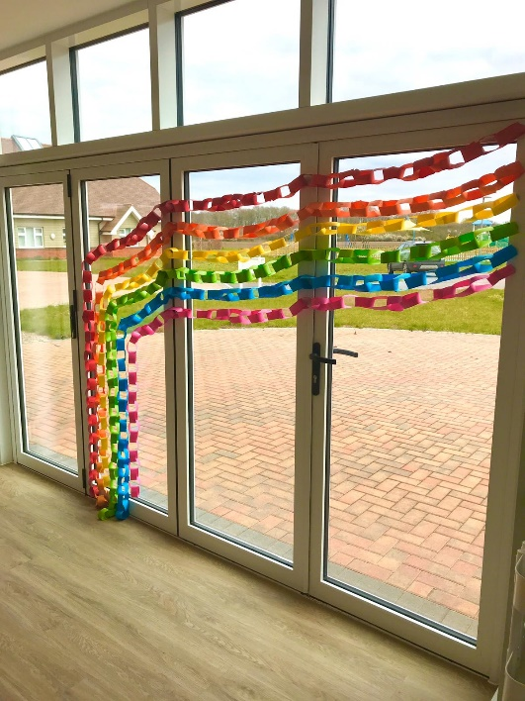**A strong focus on work / life balance, taking care of your health and planning for retirement**

Making sure our employees have a good work/life balance is vital. In addition to a wellbeing programme, we offer generous annual leave entitlement with a day off for your birthday and an extra two additional days holiday, known as Alexander days each year.

There are also staff discounts on a range of products and services including travel and high street savings.

**Further information**

**Equal opportunities**

It is the policy of Alexander Devine Children’s Hospice Service to provide equal opportunities to any employee or job applicant and will not discriminate either directly or indirectly because of race, sex, sexual orientation, transgender status, religion or belief, marital or civil partnership status, age, disability, or pregnancy and maternity.

**Safeguarding statement**

We are committed to safeguarding and promoting the welfare of children and applicants must be willing to undergo Child Protection screening appropriate to the post, including an Enhanced DBS check.

**How to apply**

For an informal discussion about the role, please call **Fiona Devine, Chief Executive, on 01628 822777**

**For an application form, please email warrenk@alexanderdevine.org**

Please send completed application forms to [warrenk@alexanderdevine.org](mailto:warrenk@alexanderdevine.org)

Applications must be received by midday on 22nd April 2025