**Application Pack**

**Corporate Fundraiser**

**Closing date for applications: 22nd April 2025**

**Alexander Devine Children’s Hospice Service**

Alexander Devine Children’s Hospice Service (Alexander Devine) is a local charity that provides specialist care and vital support to babies, children and young people with life-limiting and life-threatening conditions, and their families, across Berkshire and into surrounding counties.

We individualise our approach to meet the unique clinical, emotional and practical needs of each child and their family, ensuring they receive the best possible care and support. Our comprehensive range of care services include Respite care, Specialist play, Symptom management, Family support, End of life care and Bereavement support. We provide care from our children’s hospice in Maidenhead as well as in the family home and across the community, including hospitals and schools.

Our hospice facilities offer opportunities for children and their siblings to experience fun, joy and adventures, and help families make precious memories for as long as they have. These include a hydrotherapy pool, sensory room, music room, games room, outdoor playground and sensory garden, six children’s bedrooms and two self-contained family flats. We also have a dedicated bereavement suite with its own garden.

Our children’s hospice service is free of charge for families, but it costs over £2.8 million a year just to maintain our current level of care. With very minimal government funding, our charity is almost entirely reliant on donations, fundraising and gifts in Wills to meet the costs of running our service. Which means every penny donated makes a huge difference to those we support.

We currently support over 165 children and their families, but we are committed to growing our service and reaching out to every child and family that needs us. In Berkshire alone, we know that there are an estimated 1,371 children with life-limiting conditions. And research shows that this number is likely to increase by at least a further 11% by 2030.

The charity was founded by John and Fiona Devine in memory of their son Alexander who sadly passed away from a rare brain tumour in 2006 at the age of eight. Their personal experience led them to realise a desperate need for a local children’s hospice service with a hospice facility in Berkshire.

**www.alexanderdevine.org**

**Reg. Charity No. 1118947**

**Our values, vision and mission**

**Our values**

Our work is powered by our core values. They are key to everything that we do and the way in which we do it. Our expectation is that our values are upheld in all that we do and in our engagements, both internally and externally.

**Our vision**

We deliver palliative care to children and families through an holistic approach that meets the individual needs of each child and their family.

Our vision is to provide a service within Berkshire and surrounding counties that will give children and families a choice of care and support from a skilled and dedicated team. We work closely with the NHS, local authorities and other services in delivering our care.

**Our mission**

**Reaching out to every child and family who needs us, offering support and care from people who understand.**

**The role**

**Corporate Fundraiser**

**Hours** 37.5 hours per week (Full Time)

Part time will be considered (not less than 4 days per week)

**Salary**  Band 5 FTE: £29,749 to £36,429 per annum (pro-rata for part time)

**Location** Alexander Devine Children’s hospice in Maidenhead, Berkshire. Hybrid working will be considered, no more than 2 days per week at home.

**Benefits**  Competitive salary

Generous annual leave (plus your birthday as an additional day off)

Pension

Employee assistance programme

Death in Service Cover

Private Medical Insurance

Free on-site parking

**Job purpose**

To contribute to the overall development and the delivery of the Alexander Devine fundraising strategy by delivering the corporate fundraising strategy to maximise income from the Berkshire corporate sector.

The post holder will be responsible for managing the research and cultivation of future Corporate supporters as well as maintaining and developing current relationships.

|  |  |
| --- | --- |
| **Grade** | Corporate Fundraiser - Band 5 |
| **Managerial reporting responsibility** | Lead for Corporate and Community Partnerships, Alexander Devine Children’s Hospice Service |
| **Professional reporting responsibility** | Lead for Corporate and Community Partnerships, Alexander Devine Children’s Hospice Service |

**Job Description**

**Areas of responsibility**

1. To build and maintain relationships with existing corporate donors ensuring they feel well supported and part of a mutually beneficial partnership.
2. Supporting corporate partners to maximise their fundraising activities.
3. Maintain excellent communication/engagement with corporate and AD volunteers motivating them and showing our appreciation of their efforts.
4. To research, approach and secure new corporate partnerships across Berkshire & Thames Valley including writing and delivering corporate fundraising pitches.
5. Develop opportunities to engage with the corporate community via networking and public speaking
6. To lead on a number of Hospice led events and campaigns.
7. Develop and deliver new initiatives to engage corporate supporters including campaigns, fundraising activities, sponsorship packages and events.
8. Collaborate with the Marketing and Communications Manager to develop compelling fundraising materials, including on and offline promotional materials and social media content.
9. Research new corporate fundraising techniques and keep abreast of developments within the charity sector, hospice movement and Berkshire’s business community
10. Maintain accurate and up-to-date records of supporters, fundraising activities, income, and expenses.
11. To work collaboratively across the fundraising team and the wider organisation to support each other and maximise opportunities.
12. Manage own workload in a cost effective and proactive way
13. Stay up-to-date with fundraising trends, best practices, and regulatory requirements in the charity sector, ensuring compliance with relevant laws and guidelines.

**This job description reflects the present requirements of the post. As duties and responsibilities change and develop, the job description will be reviewed and is subject to amendment in consultation with the post holder.**

**Duties in common with other members of staff**

* Contribute positively to good teamwork.
* To report and record accidents and incidents.
* To be an ambassador for the charity.
* To maintain the best appearance of your immediate working area.
* To demonstrate a positive and supportive attitude to staff and volunteers.
* Respect confidentiality applying to all areas of the hospice.
* To adhere to the Infection Control Policies and Procedures set by the charity and the Care Quality Commission.
* A commitment to, attitude and behaviour that reflects our core values - Determined, Empowering, Valuing others. Integrity, Nurture, Empathy.
* Commitment to ensuring your own wellbeing and that of your colleagues.

**This job description reflects the present requirements of the post. As duties and responsibilities change and develop, the job description will be reviewed and is subject to amendment in consultation with the post holder.**

**Person specification**

|  |  |  |
| --- | --- | --- |
|  | **Essential** | **Desirable** |
| **Education, training and qualifications** | English Language and Mathematics GCSE or equivalent grade C (grade 4) or above  Excellent administrative skills  Demonstrable proficiency in intermediate IT skills including Microsoft Office, Outlook, Excel, PowerPoint and a CRM database. | Institute of Fundraisers Certificate or equivalent. |
| **Experience** | Previous experience in a similar role or transferable skills  Excellent interpersonal skills, communication skills, and organisation skills | Experience of successful new business development and account management.  Experience of working in a target driven environment, with a proven track record of successfully achieving income against target. |
| **Skills** | Proven ability in building relationships both internally and externally  Personable and confident character able to engage supporters and build effective relationships on the phone and face to face.  Confident in networking and operating at senior levels  Strong organisational skills  Excellent presentation skills  Proven ability to work as part of a team and own initiative  Knowledge of social media and digital tools, platforms and techniques.  Ability to work well under own initiative with minimum supervision, cope well with managing deadlines and juggle numerous marketing and fundraising demands at once. | Event management experience  Ability to write compelling and impactful applications and reports  Basic design skills and comfort using online tools such as Canva |
|  | **Essential** | **Desirable** |
| **Other** | Car driver - vehicle available for working  Ability to work flexible working hours  Commitment to the mission and ethos of Alexander Devine Children’s Hospice Service  Able to work within and uphold our core values : determined, empowering, valuing others, integrity, nurture and empathy  Ability to work alone and as a member of a team.  Able to assess risk to maintain personal safety in a variety of settings  Ability to cope with the physical demands expected of the role e.g. moving and handling,  Willing to undertake an Enhanced DBS  Passed fit to undertake the duties of the post by Occupational Health |  |

**A rewarding and special place to work**

Finding ways to recognise, reward and support every member of our team is important to us. Here’s four big reasons why you will want to join our charity…

**The amazing people that work here**

Very simply, the team at Alexander Devine makes our charity such a unique place to work. To quote one of the young people that we support:

*“If I had to summarise what makes Alexander Devine so special, I would say it’s the people that work there…they are like family to us”*

Whichever part of the charity you are working or if you

are a volunteer, we are proud of our ‘one team’ spirit.

**An employer that listens and cares**

We pride ourselves on ensuring our staff receive regular supervision and support from their line manager, with opportunities for further training and development.

We also have an employee assistance programme, offering our employees a free confidential advisory and counselling service to help with any personal, work or family issues they may face.

**A beautiful setting in a convenient location**

Our stunning purpose-built hospice is surrounded by beautiful countryside, but also just a stones throw from the M4 and A404, on the outskirts of Maidenhead.

There is free on-site parking for all staff.

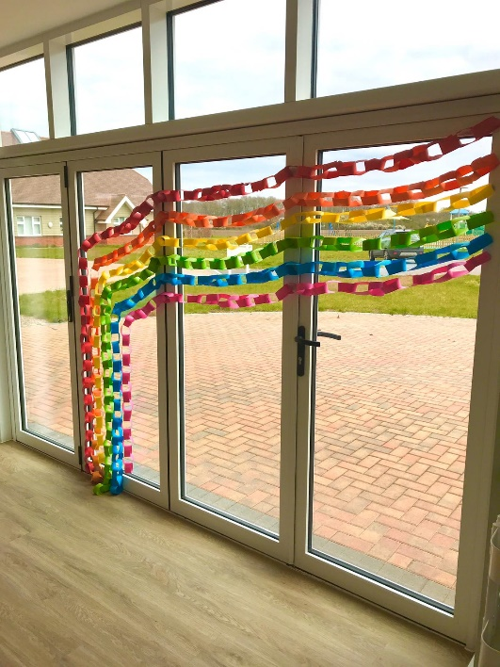**A strong focus on work / life balance, taking care of your health and planning for retirement**

Making sure our employees have a good work/life balance is vital. In addition to a wellbeing programme, we offer generous annual leave entitlement with a day off for your birthday and an extra two additional days holiday, known as Alexander days each year.

There are also staff discounts on a range of products and services including travel and high street savings.

**Further information**

**Equal opportunities**

It is the policy of Alexander Devine Children’s Hospice Service to provide equal opportunities to any employee or job applicant and will not discriminate either directly or indirectly because of race, sex, sexual orientation, transgender status, religion or belief, marital or civil partnership status, age, disability, or pregnancy and maternity.

**Safeguarding statement**

We are committed to safeguarding and promoting the welfare of children and applicants must be willing to undergo Child Protection screening appropriate to the post, including an Enhanced DBS check.

**How to apply**

For an informal discussion about the role, please call Anne Bajorek, Director of Fundraising**, on 01628 822777** or email questions to[**anneb@alexanderdevine.org**](mailto:anneb@alexanderdevine.org)

For an application form, please email [fayd@alexanderdvine.org](mailto:fayd@alexanderdvine.org)

Completed applications must be returned to [fayd@alexanderdevine.org](mailto:fayd@alexanderdevine.org), by midday on **22nd April 2025**