**Application Pack**

**Community Fundraiser**

**Closing date for applications: Monday 13th October 2025**

**Alexander Devine Children’s Hospice Service**

Alexander Devine Children’s Hospice Service (Alexander Devine) is a local charity that provides specialist care and vital support to babies, children and young people with life-limiting and life-threatening conditions, and their families, across Berkshire and into surrounding counties.

We individualise our approach to meet the unique clinical, emotional and practical needs of each child and their family, ensuring they receive the best possible care and support. Our comprehensive range of care services include Respite care, Specialist play, Symptom management, Family support, End of life care and Bereavement support. We provide care from our children’s hospice in Maidenhead as well as in the family home and across the community, including hospitals and schools.

Our hospice facilities offer opportunities for children and their siblings to experience fun, joy and adventures, and help families make precious memories for as long as they have. These include a hydrotherapy pool, sensory room, music room, games room, outdoor playground and sensory garden, six children’s bedrooms and two self-contained family flats. We also have a dedicated bereavement suite with its own garden.

Our children’s hospice service is free of charge for families, but it costs over £2.8 million a year just to maintain our current level of care. With very minimal government funding, our charity is almost entirely reliant on donations, fundraising and gifts in Wills to meet the costs of running our service. Which means every penny donated makes a huge difference to those we support.

We currently support over 165 children and their families, but we are committed to growing our service and reaching out to every child and family that needs us. In Berkshire alone, we know that there are an estimated 1,371 children with life-limiting conditions. And research shows that this number is likely to increase by at least a further 11% by 2030.

The charity was founded by John and Fiona Devine in memory of their son Alexander who sadly passed away from a rare brain tumour in 2006 at the age of eight. Their personal experience led them to realise a desperate need for a local children’s hospice service with a hospice facility in Berkshire.

**www.alexanderdevine.org**

**Reg. Charity No. 1118947**

**Our values, vision and mission**

**Our values**

Our work is powered by our core values. They are key to everything that we do and the way in which we do it. Our expectation is that our values are upheld in all that we do and in our engagements, both internally and externally.

**Our vision**

We deliver palliative care to children and families through an holistic approach that meets the individual needs of each child and their family.

Our vision is to provide a service within Berkshire and surrounding counties that will give children and families a choice of care and support from a skilled and dedicated team. We work closely with the NHS, local authorities and other services in delivering our care.

**Our mission**

**Reaching out to every child and family who needs us, offering support and care from people who understand.**

**The role**

**Community Fundraiser**

**Hours** Up to 37.5 hours per week (will include some weekend and out of hours working).

Part time working will be considered, no less than 4 days per week.

**Salary** Band 5: £30,641 to £37,522 per annum, pro-rata for part time

**Location** Alexander Devine Children’s hospice in Maidenhead, Berkshire

Occasional working from home will be considered

**Benefits**  Competitive salary

Generous annual leave (plus your birthday as an additional day off)

Pension

Employee assistance programme

Death in Service Cover

Private Medical Insurance

Free on-site parking

**Job purpose**

To contribute to the Alexander Devine fundraising strategy by developing and delivering the community fundraising programme

|  |  |
| --- | --- |
| **Grade** | Community Fundraiser - Band 5 |
| **Managerial reporting responsibility** | Lead for Community Fundraising, Alexander Devine Children’s Hospice Service |
| **Professional reporting responsibility** | Lead for Community Fundraising, Alexander Devine Children’s Hospice Service |
| **Direct Reports** | N/A |

**Job Description**

**Areas of responsibility**

1. Identify, build and maintain strong relationships with individuals, community groups, schools, businesses, and local organisations to create fundraising opportunities and secure support.
2. Support the Lead for Community in developing and implementing creative and effective fundraising initiatives, including events, challenges, appeals, and partnerships, to maximise income generation and donor engagement.
3. Provide guidance, support, and resources to individuals and groups organizing community-led fundraising activities on behalf of the charity.
4. To lead on a number of Hospice led events.
5. Develop relationships with the organisers of local community fetes, carnivals and fairs and attend a number of these events through the year to fundraise for Alexander Devine
6. To support AD Volunteers to nurture their continued support and assistance.
7. Collaborate with the Marketing and Communications Manager to develop compelling fundraising materials, including promotional materials, online campaigns, and social media content.
8. Maintain accurate and up-to-date records of supporters, fundraising activities, income, and expenses
9. To work collaboratively across the fundraising team and the wider organisation to support each other and maximise opportunities.
10. Represent the charity at community events, meetings, and networking opportunities, delivering engaging presentations to inspire support and promote the charity's work.
11. Stay up-to-date with fundraising trends, best practices, and regulatory requirements in the charity sector, ensuring compliance with relevant laws and guidelines.

**Duties in common with other members of staff**

* Contribute positively to good teamwork.
* A commitment to, attitude and behaviour that reflects our core values - Determined, Empowering, Valuing others. Integrity, Nurture, Empathy.
* Commitment to ensuring your own wellbeing and that of your colleagues.
* To report and record accidents and incidents.
* To be an ambassador for the charity.
* To uphold and demonstrate the values of the charity.
* To maintain the best appearance of your immediate working area.
* To demonstrate a positive and supportive attitude to staff and volunteers.
* Respect confidentiality applying to all areas of the hospice.
* To adhere to the Infection Control Policies and Procedures set by the charity and the Care Quality Commission.

**This job description reflects the present requirements of the post. As duties and responsibilities change and develop, the job description will be reviewed and is subject to amendment in consultation with the post holder.**

**Person specification**

|  |  |  |
| --- | --- | --- |
|  | **Essential** | **Desirable** |
| **Education, training and qualifications** | English Language and Mathematics GCSE or equivalent grade C (grade 4) or above  Excellent administrative skills  Demonstrable proficiency in intermediate IT skills including Microsoft Office, Outlook, Access, Excel, PowerPoint, Publisher and a CRM database. | Chartered Institute of Fundraising Certificate or equivalent. |
| **Experience** | Experience in fundraising, or transferable skills from a role focused on developing relationships and engaging with the public.  Event and/or project management experience. | Experience managing volunteers  Experience in planning and delivering energetic, community-focused fundraising events that inspire participation and maximise engagement |
| **Skills** | Ability to engage and inspire diverse groups of individuals and organisations.  Good communication skills, both written and verbal, with the ability to deliver engaging presentations.  Self-motivated, able to take initiative and work without regular prompting  Organised approach and ability to work to tight deadlines in a fast pace and unpredictable environment  Ability to work well under own initiative with minimum supervision, cope well with managing deadlines and juggle numerous marketing and fundraising demands at once. |  |
|  | **Essential** | **Desirable** |
| **Other** | Car driver and vehicle available for working.  Flexible schedule to accommodate evening and weekend events particularly during summer months and the pre-Christmas period. (Time off in lieu will be given)  Commitment to the mission and ethos of Alexander Devine Children’s Hospice Service  Able to work within and uphold our core values: determined, empowering, valuing others, integrity, nurture and empathy.  Ability to work alone and as a member of a team.  Able to assess risk to maintain personal safety in a variety of settings.  Ability to cope with the physical demands expected of the role e.g. moving and handling.  Willing to undertake an Enhanced DBS.  Passed fit to undertake the duties of the post by Occupational Health. |  |

**A rewarding and special place to work**

Finding ways to recognise, reward and support every member of our team is important to us. Here’s four big reasons why you will want to join our charity…

**The amazing people that work here**

Very simply, the team at Alexander Devine makes our charity such a unique place to work. To quote one of the young people that we support:

*“If I had to summarise what makes Alexander Devine so special, I would say it’s the people that work there…they are like family to us”*

Whichever part of the charity you are working or if you

are a volunteer, we are proud of our ‘one team’ spirit.

**An employer that listens and cares**

We pride ourselves on ensuring our staff receive regular supervision and support from their line manager, with opportunities for further training and development.

We also have an employee assistance programme, offering our employees a free confidential advisory and counselling service to help with any personal, work or family issues they may face.

**A beautiful setting in a convenient location**

Our stunning purpose-built hospice is surrounded by beautiful countryside, but also just a stones throw from the M4 and A404, on the outskirts of Maidenhead.

There is free on-site parking for all staff.

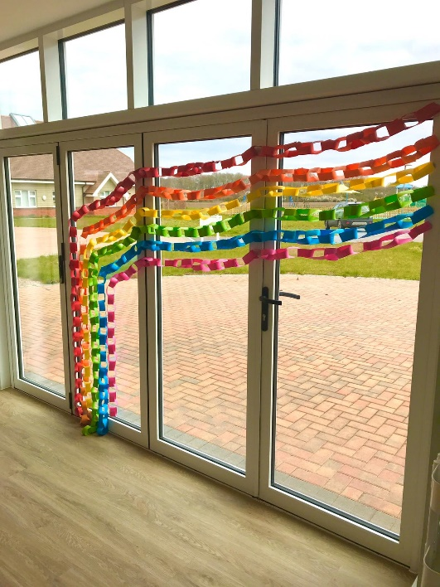**A strong focus on work / life balance, taking care of your health and planning for retirement**

Making sure our employees have a good work/life balance is vital. In addition to a wellbeing programme, we offer generous annual leave entitlement with a day off for your birthday and an extra two additional days holiday, known as Alexander days each year.

There are also staff discounts on a range of products and services including travel and high street savings.

**Further information**

**Equal opportunities**

It is the policy of Alexander Devine Children’s Hospice Service to provide equal opportunities to any employee or job applicant and will not discriminate either directly or indirectly because of race, sex, sexual orientation, transgender status, religion or belief, marital or civil partnership status, age, disability, or pregnancy and maternity.

**Safeguarding statement**

We are committed to safeguarding and promoting the welfare of children and applicants must be willing to undergo Child Protection screening appropriate to the post, including an Enhanced DBS check.

**How to apply**

For an informal discussion about the role, please call Anne Bajorek, Director of Fundraising **on 01628 822777** or email questions to[**anneb@alexanderdevine.org**](mailto:anneb@alexanderdevine.org)

For an application form, please visit [www.alexanderdevine.org/join-the-team/](http://www.alexanderdevine.org/join-the-team/)

Completed application forms must be returned to [fayd@alexanderdevine.org](mailto:fayd@alexanderdevine.org), no later than midday on Monday 13th October 2025.