



Application Pack
Alexander’s Nurse (Band 6)

Alexander Devine Children’s Hospice Service

Alexander Devine Children’s Hospice Service (Alexander Devine) is a local charity that provides specialist care and vital support to babies, children and young people with life-limiting and life-threatening conditions, and their families, across Berkshire, South Bucks and into surrounding counties.

We individualise our approach to meet the unique clinical, emotional, and practical needs of each child and their family, ensuring they receive the best possible care and support. Our comprehensive range of care services include Respite care, Specialist play, Symptom management, Family support, End of life care and Bereavement support. We provide care from our children’s hospice in Maidenhead as well as in the family home and across the community, including hospitals and schools.

Our hospice facilities offer opportunities for children and their siblings to experience fun, joy and adventures, and help families make precious memories for as long as they have. These include a hydrotherapy pool, sensory room, music room, games room, outdoor playground and sensory garden, six children’s bedrooms and two self-contained family flats. We also have a dedicated bereavement suite with its own garden.

Our children’s hospice service is free of charge for families, but it costs over £2.8 million a year just to maintain our current level of care. With very minimal government funding, our charity is almost entirely reliant on donations, fundraising and gifts in Wills to meet the costs of running our service. Which means every penny donated makes a huge difference to those we support.

We currently support over 200 children and their families, but we are committed to growing our service and reaching out to every child and family that needs us. In Berkshire alone, we know that there are an estimated 1,371 children with life-limiting conditions. And research shows that this number is likely to increase by at least a further 11% by 2030.

The charity was founded by John and Fiona Devine in memory of their son Alexander who sadly passed away from a rare brain tumour in 2006 at the age of eight. Their personal experience led them to realise a desperate need for a local children’s hospice service with a hospice facility in Berkshire.

www.alexanderdevine.org
Reg. Charity No. 1118947
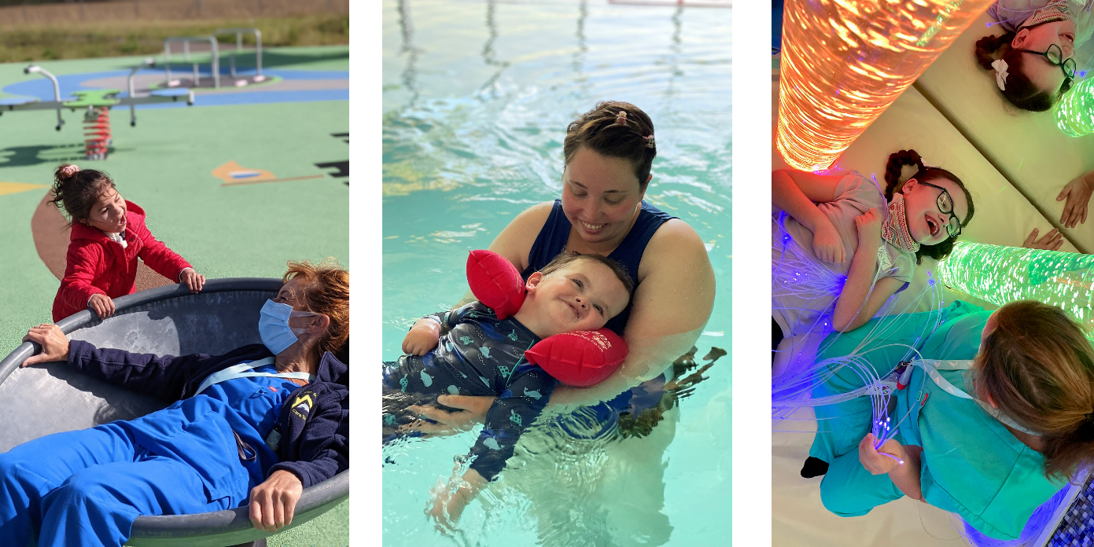

Our values, vision, and mission

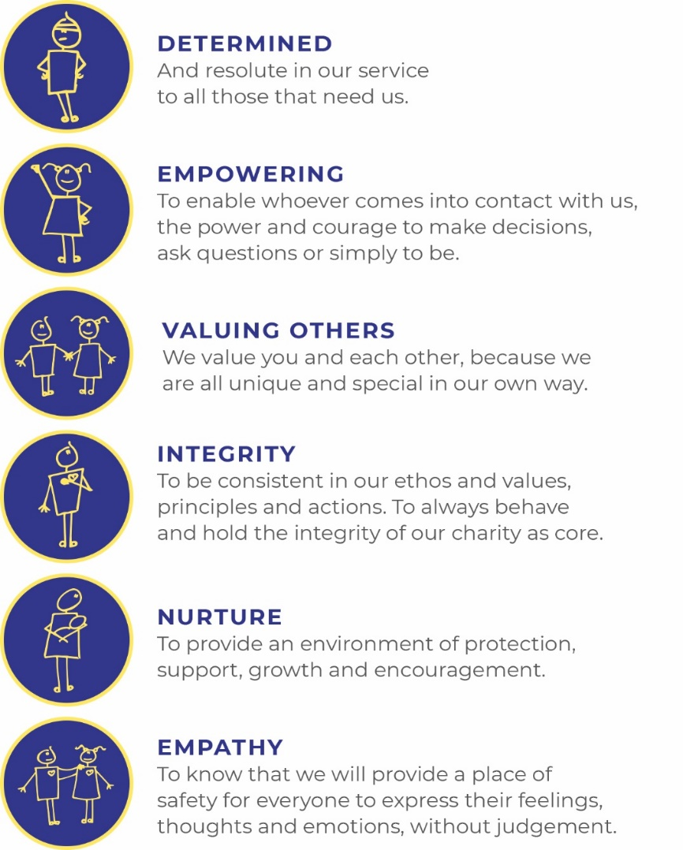
Our values
Our work is powered by our core values. They are key to everything that we do and the way in which we do it. Our expectation is that our values are upheld in all that we do and in our engagements, both internally and externally.

Our vision
We deliver palliative care to children and families through an holistic approach that meets the individual needs of each child and their family.

Our vision is to provide a service within Berkshire and surrounding counties that will give children and families a choice of care and support from a skilled and dedicated team. We work closely with the NHS, local authorities, and other services in delivering our care.

Our mission
Reaching out to every child and family who needs us, offering support and care from people who understand.

Job Description
Job Title: | Alexander’s Nurse – Children’s Palliative Care Nurse
Grade: | Band 6  £38,293 - £46,794 per annum
Accountable to: | Director of Care, Alexander Devine Children’s Hospice Service
Job Purpose: | Working as part of the Alexander’s Care Team this post is to provide holistic care and support to children with a life threatening and life limiting condition [LT/LL] and their families across the geographical area supported by Alexander Devine Children’s Hospice Service.  The post will involve a flexible, needs led approach to care delivery, contributing to a 24/7 rota by the Alexander’s Care Team. The post holder will assess children and families and identify the need for short break respite provision, palliative and end of life care in the child’s home or other community setting and in the hospice, working both autonomously and in collaboration with other agencies.

Core Responsibilities

Managerial:

- Works collaboratively with the Alexander’s Care Team to develop and maintain a strategy that meets the needs of children and families.

- Works both as an independent practitioner, and as an effective member of the wider interdisciplinary clinical team.

- Maintains high quality in all areas of work and practice, supporting the development of quality in the organisation.

- Participates in all areas of audit and risk management and uses data from audit / quality monitoring/ patient satisfaction questionnaires /service review to inform clinical governance and service improvement.

- Ensures patients are consulted in the development of services and utilises information to ensure that services are responsive to patient needs.

- Is responsible for ensuring own clinical practice complies with Data Protection, Confidentiality and Caldicott principles.

- Actively promotes diversity, in the delivery of services, in the development of staff and within the organisation. Supports and sustains relationships that promote dignity, rights and responsibilities. Identifies and takes action to address discrimination and oppression.

- Monitors and maintains the health, safety and security of self and any practitioners he/ she is responsible for in work area. Identifies and assesses risks in work activities, and develops strategies to manage these effectively. Practices within risk management/ occupational health legislation and Organisational procedures.

- Develops own skills, taking responsibility for continuing professional development and performance, maintaining own portfolio in accordance with post registration requirements. Works to achieve competencies appropriate to grade and role. Identifies own development needs in relation to current practice and future plans, setting personal development objectives.

- Represents Alexander Devine Children’s Hospice Service [ADCHS] at interagency meetings as requested.

- Demonstrates commitment to the values of ADCHS and the ethos of hospice care.

- Actively promotes Alexander Devine Children’s Hospice Service and supports the development of children’s palliative care across Berkshire

- Contributes to fundraising initiatives for the ADCHS.

Clinical:

- Holds own defined caseload and Works flexibly to support 24/7 rotas, emergency and end of life care.

- Communicates complex, sensitive information effectively and empathetically to patients and relatives, managing difficult situations and maintains the highest standards when communicating with children, families and the wider public.

- Completes and maintains up to date records in line with principles of best practice.

- Actively manages assessment, evaluation and the delivery of care, promoting all elements of high quality care planning.

- Leads on developing the health component of the care package for the family working with other agencies to develop a holistic package.

- Supports families throughout the care pathway including initial diagnosis and discharge planning form hospital to community.

- Works flexibly to plan appropriate intervention where there may be escalation of symptoms or family difficulties and offers support to families as needed.

- Checks and administers medication to children in their own home in line with ADCHS Medicines Management policy.

- Works as an expert practitioner in palliative care acting as a resource for other healthcare professionals.

- Assumes a central role in problem solving and service co-ordination to ensure patients and carers receive high standards of seamless quality care.

- Works with non-specialist interdisciplinary practitioners to complement their care, and the quality of the service provided.

- Actively participates in interdisciplinary meetings.

- Acts on clinical incidents pertinent to area, to reduce clinical risk.

- Is familiar with ADCHS safeguarding policy and report any concerns accordingly.

Teaching, Training and Research:

- Establishes local and national networks, linking with other practitioners in specialist area in order to share/ learn from examples of good practice.

- Provides informal support and education to patients/ carers and all professionals as appropriate.

- Participates in the delivery and evaluation of formal education programmes related to palliative and end of life care.

- Identifies and plans education, participating in planning and delivery.

- Conducts/facilitates primary research/ contributes to research programmes. Promotes evidence based practice in palliative and end of life care. Is aware of clinical trials that may affect patients in own clinical area.

- Uses reflective practice, evaluation and research findings critically to contribute to the improvement of services.

- Provides formal mentorship and clinical supervision to other members of the Alexander’s Care Team.

- Develops specialist policies, guidelines and care procedures for the organisation and supports the development of care pathways.

- Develops and contributes to an information database of support services available to health care professionals and patient group.

This job description reflects the present requirements of the post. As duties and responsibilities change and develop, the job description will be reviewed and is subject to amendment in consultation with the post holder

Personal Specification
Alexander’s Nurse – Children’s Palliative Care Community Nurse – Band 6

 | Essential | Desirable
Education/ Qualifications/ Training: | - RSCN or RN (Child) degree or diploma level  - ENB 998 or equivalent teaching and assessing qualification  - Evidence of continual professional development and education | - Relevant specialist course eg palliative care and/or advanced communications  - Community qualification
Experience: | - Significant post registration experience.  - Experience of needs assessment/care planning. Caseload management  - Experience of interagency working  - Experience working in community setting  - Experience of provision of training/education to a range of staff and patients.  - Experience of caring for children and families with LL/LT conditions including assessment and symptom management | - Experience caring for children with complex health needs  - Caring for children at the end of life
Skills | - Demonstrates ability to place patient and family at centre of care.  - Excellent personal and communication skills.  - Good facilitation/ presentation, teaching and assessing skills.  - Excellent organisational ability.  - Motivated and enthusiastic.  - Creative, resourceful and imaginative  - Excellent role model  - Ability to critically analyse research and evidence based practice  - Knowledge and understanding of safeguarding  - Familiarity of systems for quality control, clinical governance and clinical audit
Other | - Car driver - vehicle available for working  - Flexible working hours contributing to 24/7 rotas  - Commitment to the mission and ethos of Alexander Devine Children’s Hospice Service  - Able to work within and uphold our core values : determined, empowering, valuing others, integrity, nurture and empathy  - Ability to work alone and as a member of a team.  - Able to assess risk to maintain personal safety in a  variety of settings  - Ability to cope with the physical demands expected of the role e.g. shift work, moving and handling, clinical and caring procedures  - Good IT skills  - Enhanced DBS  - Passed fit to undertake the duties of the post by Occupational Health

Further information

Equal opportunities
It is the policy of Alexander Devine Children’s Hospice Service to provide equal opportunities to any employee or job applicant and will not discriminate either directly or indirectly because of race, sex, sexual orientation, transgender status, religion or belief, marital or civil partnership status, age, disability, or pregnancy and maternity.

Safeguarding statement
We are committed to safeguarding and promoting the welfare of children and applicants must be willing to undergo Child Protection screening appropriate to the post, including checks with the Disclosure and Barring Service.

Applications
To apply, please email fayd@alexanderdevine.org to request an application form.
Once complete, please post to:
Fay Denwood
Alexander Devine Children’s Hospice Service
Snowball Hill
SL6 3LU

Alternatively, completed forms can be emailed to fayd@alexanderdevine.org
Applications must be received by midday Monday XXXXXX

