



Application Pack
Director of Finance
Closing date for applications: 23rd March 2026
Alexander Devine Children’s Hospice Service

Alexander Devine Children’s Hospice Service (Alexander Devine) is a local charity that provides specialist care and vital support to babies, children and young people with life-limiting and life-threatening conditions, and their families, across Berkshire, South Bucks and into surrounding counties.

We individualise our approach to meet the unique clinical, emotional, and practical needs of each child and their family, ensuring they receive the best possible care and support. Our comprehensive range of care services include Respite care, Specialist play, Symptom management, Family support, End of life care and Bereavement support. We provide care from our children’s hospice in Maidenhead as well as in the family home and across the community, including hospitals and schools.

Our hospice facilities offer opportunities for children and their siblings to experience fun, joy and adventures, and help families make precious memories for as long as they have. These include a hydrotherapy pool, sensory room, music room, games room, outdoor playground and sensory garden, six children’s bedrooms and two self-contained family flats. We also have a dedicated bereavement suite with its own garden.

Our children’s hospice service is free of charge for families, but it costs over £2.8 million a year just to maintain our current level of care. With very minimal government funding, our charity is almost entirely reliant on donations, fundraising and gifts in Wills to meet the costs of running our service. Which means every penny donated makes a huge difference to those we support.

We currently support over 200 children and their families, but we are committed to growing our service and reaching out to every child and family that needs us. In Berkshire alone, we know that there are an estimated 1,371 children with life-limiting conditions. And research shows that this number is likely to increase by at least a further 11% by 2030.

The charity was founded by John and Fiona Devine in memory of their son Alexander who sadly passed away from a rare brain tumour in 2006 at the age of eight. Their personal experience led them to realise a desperate need for a local children’s hospice service with a hospice facility in Berkshire.

www.alexanderdevine.org
Reg. Charity No. 1118947


Our values, vision, and mission

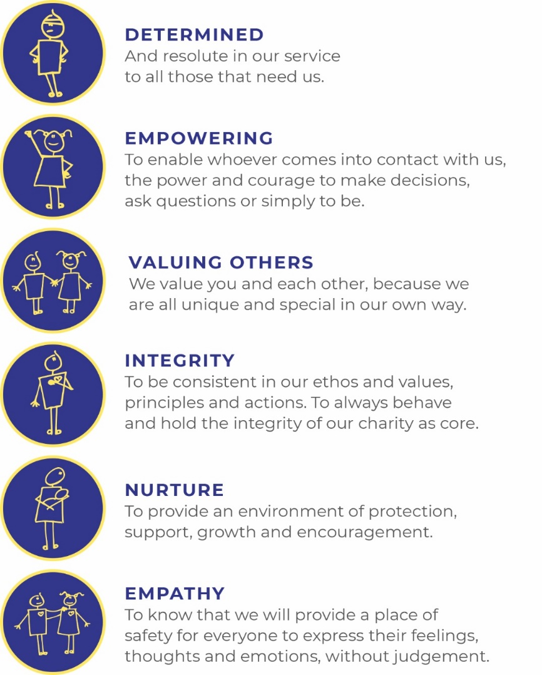
Our values
Our work is powered by our core values. They are key to everything that we do and the way in which we do it. Our expectation is that our values are upheld in all that we do and in our engagements, both internally and externally.

Our vision
We deliver palliative care to children and families through an holistic approach that meets the individual needs of each child and their family.

Our vision is to provide a service within Berkshire and surrounding counties that will give children and families a choice of care and support from a skilled and dedicated team. We work closely with the NHS, local authorities, and other services in delivering our care.

Our mission
Reaching out to every child and family who needs us, offering support and care from people who understand.

The role
Director of Finance
Hours Part time - 22.5 hours per week.
Salary £42,000 (£70,000 pro rata)
Location Alexander Devine Children’s Hospice in Maidenhead, Berkshire.
Benefits Competitive salary
Generous annual leave (plus your birthday as an additional day off)
Pension
Employee assistance programme
Death in Service Cover
Free on-site parking
Staff discounts

Job purpose
The Director of Finance is responsible for the strategic direction and long-term financial viability of the charity with the operational responsibility for the provision of finance, contractual and associated services to the charity.

Grade | Director spot salary - £42,000 (£70,000 pro rata)
Managerial reporting responsibility | Chief Executive
Professional reporting responsibility | Chief Executive
Managerial responsibility | Financial Controller

Job Description
Areas of responsibility

General

- Provide strategic financial leadership to ensure the long-term sustainability and financial resilience of the charity.

- Lead on the development and delivery of the organisation’s financial strategy in support of the overall strategic plan.

- Act as a key member of the Senior Management Team (SMT), contributing to organisational strategy, risk management and performance improvement.

- Advise the Chief Executive, Board of Trustees and sub-committees on all financial matters, ensuring robust governance and compliance.

- Lead the annual budgeting and business planning process, ensuring alignment with strategic objectives and operational priorities.

- Running payroll and expenses on a regular basis.

- Produce timely, accurate and meaningful monthly management accounts and financial reports, including variance analysis and forecasts.

- Ensure full compliance with charity accounting standards (Charities SORP), statutory requirements and regulatory bodies.

- Lead on the preparation of statutory accounts and manage relationships with external auditors and professional advisers.

- Liaise with external insurance brokers to ensure full and cost-effective insurance cover for the charity, its buildings, staff and activities.

- Oversee treasury management, cash flow forecasting and reserves management to ensure financial stability.

- Ensure appropriate financial controls, systems and processes are in place and regularly reviewed.

- Develop financial modelling to support service growth, investment decisions and income generation strategies.

- Lead on financial risk management, ensuring risks are identified, mitigated and reported appropriately.

- Oversee contract management processes (including with partner organisations such as the NHS) to ensure value for money and compliance.

- Ensure effective financial support for capital projects and future development opportunities.

- Present financial information clearly and confidently to a range of stakeholders, including Trustees and external partners.

- Manage cashflow including ensuring all cash and cheques received are counted and banked in a timely manner.

General Requirements in line with all staff

- Responsible for ensuring own practice complies with Data Protection, Confidentiality.

- Keep accurate and legible records supporting data collection.

- Maintain confidentiality in all areas of work.

- Be familiar with and adhere to all the Charity’s policies and procedures.

- Promote safeguarding and welfare of children, young people and their families.

- Adhere to Health and Safety regulations.

- Represents Alexander Devine Children’s Hospice Service (ADCHS) at interagency meetings as requested.

- Demonstrates commitment to the values of ADCHS and the ethos of hospice care.

- Actively promotes ADCHS and supports the development of children’s palliative care across Berkshire.

- Contributes to fundraising initiatives for the ADCHS.

The post holder must act at all times in a professional and responsible manner and have due regard to confidentiality and Health & Safety legislation.

This is an outline job description and should not be regarded as an inflexible specification. Responsibilities will be reviewed periodically in line with service priorities and duties may change or new duties be introduced after consultation with the post holder. As a term of your employment you may be required to undertake such other duties, and/or hours of work as may reasonably be required, commensurate with your general level of responsibility with the organisation.

Person specification
 | Essential | Desirable
Education, training, and qualifications | Fully qualified accountant (ACA, ACCA, CIMA or equivalent).  Evidence of continued professional development. | Postgraduate qualification or leadership qualification.  Charity finance qualification or specific training in charity accounting (Charities SORP).
Experience | Significant senior financial leadership experience, ideally at Director or Head of Finance level.  Experience of strategic financial planning and leading budgeting processes.  Experience of preparing statutory accounts and working with auditors.  Experience of financial reporting to Boards or Trustees.  Experience of developing and maintaining strong financial controls and governance frameworks.  Experience of managing and developing finance staff. | Experience within the charity, hospice, healthcare or not-for-profit sector.  Experience in an organisation reliant on fundraising and voluntary income.  Experience of supporting capital projects or service expansion.  Experience of working with multiple income streams including grants, donations and contracts.  Experience of VAT partial exemption  Experience of a subsidiary trading company  Experience of claiming gift aid.
Skills | Strong strategic thinking with the ability to translate strategy into financial plans.  Excellent analytical and financial modelling skills.  Ability to communicate complex financial information clearly to non-financial stakeholders.  High level of integrity and sound judgement.  Strong leadership and influencing skills.  Excellent organisational and time management skills.  Proficiency in financial systems and Microsoft Excel. | Experience of implementing or improving financial systems.  Advanced financial modelling capability.  Experience of Xero accounting software
 | Essential | Desirable
Other | Commitment to the values of Alexander Devine Children’s Hospice Service.  Understanding of the importance of safeguarding and confidentiality.  Ability to build strong working relationships across teams and with external stakeholders.  Flexible and adaptable approach. | Local knowledge of Berkshire and surrounding counties.  Experience of working within a values-driven organisation supporting vulnerable children and families.

A rewarding and special place to work
Finding ways to recognise, reward and support every member of our team is important to us. Here’s four big reasons why you will want to join our charity…

The amazing people that work here
Very simply, the team at Alexander Devine makes our charity such a unique place to work. To quote one of the young people that we support:
“If I had to summarise what makes Alexander Devine so special, I would say it’s the people that work there…they are like family to us”
Whichever part of the charity you are working or if you
are a volunteer, we are proud of our ‘one team’ spirit.

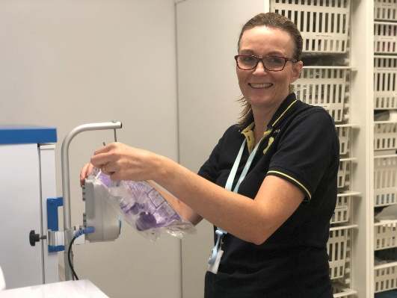
An employer that listens and cares
We pride ourselves on ensuring our staff receive regular supervision and support from their line manager, with opportunities for further training and development.
We also have an employee assistance programme, offering our employees a free confidential advisory and counselling service to help with any personal, work or family issues they may face.


A beautiful setting in a convenient location
Our stunning purpose-built hospice is surrounded by beautiful countryside, but also just a stone’s throw from the M4 and A404, on the outskirts of Maidenhead.
There is free on-site parking for all staff.


A strong focus on work / life balance, taking care of your health and planning for retirement
Making sure our employees have a good work/life balance is vital. In addition to a wellbeing programme, we offer generous annual leave entitlement with a day off for your birthday and an extra two additional days holiday, known as Alexander days each year.
There are also staff discounts on a range of products and services including travel and high street savings.
Further information

Equal opportunities
It is the policy of Alexander Devine Children’s Hospice Service to provide equal opportunities to any employee or job applicant and will not discriminate either directly or indirectly because of race, sex, sexual orientation, transgender status, religion, or belief, marital or civil partnership status, age, disability, or pregnancy and maternity.

Safeguarding statement
We are committed to safeguarding and promoting the welfare of children and applicants must be willing to undergo Child Protection screening appropriate to the post, including an Enhanced DBS check.

How to apply
For an informal discussion about the role, please call Fiona Devine, Chief Executive, on 01628 822777 or email questions to fionad@alexanderdevine.org
For an application form, please email fayd@alexanderdvine.org
CVs will not be accepted without the completion of our application form
Completed applications must be returned to fayd@alexanderdevine.org, by midday on Monday 23rd March 2026.

