



Application Pack
Team Leader (Care)
Closing date for applications: Monday 30th March 2026
Alexander Devine Children’s Hospice Service

Alexander Devine Children’s Hospice Service (Alexander Devine) is a local charity that provides specialist care and vital support to babies, children and young people with life-limiting and life-threatening conditions, and their families, across Berkshire, South Bucks and into surrounding counties.

We individualise our approach to meet the unique clinical, emotional, and practical needs of each child and their family, ensuring they receive the best possible care and support. Our comprehensive range of care services include Respite care, Specialist play, Symptom management, Family support, End of life care and Bereavement support. We provide care from our children’s hospice in Maidenhead as well as in the family home and across the community, including hospitals and schools.

Our hospice facilities offer opportunities for children and their siblings to experience fun, joy and adventures, and help families make precious memories for as long as they have. These include a hydrotherapy pool, sensory room, music room, games room, outdoor playground and sensory garden, six children’s bedrooms and two self-contained family flats. We also have a dedicated bereavement suite with its own garden.

Our children’s hospice service is free of charge for families, but it costs over £2.8 million a year just to maintain our current level of care. With very minimal government funding, our charity is almost entirely reliant on donations, fundraising and gifts in Wills to meet the costs of running our service. Which means every penny donated makes a huge difference to those we support.

We currently support over 200 children and their families, but we are committed to growing our service and reaching out to every child and family that needs us. In Berkshire alone, we know that there are an estimated 1,371 children with life-limiting conditions. And research shows that this number is likely to increase by at least a further 11% by 2030.

The charity was founded by John and Fiona Devine in memory of their son Alexander who sadly passed away from a rare brain tumour in 2006 at the age of eight. Their personal experience led them to realise a desperate need for a local children’s hospice service with a hospice facility in Berkshire.

www.alexanderdevine.org
Reg. Charity No. 1118947


Our values, vision, and mission

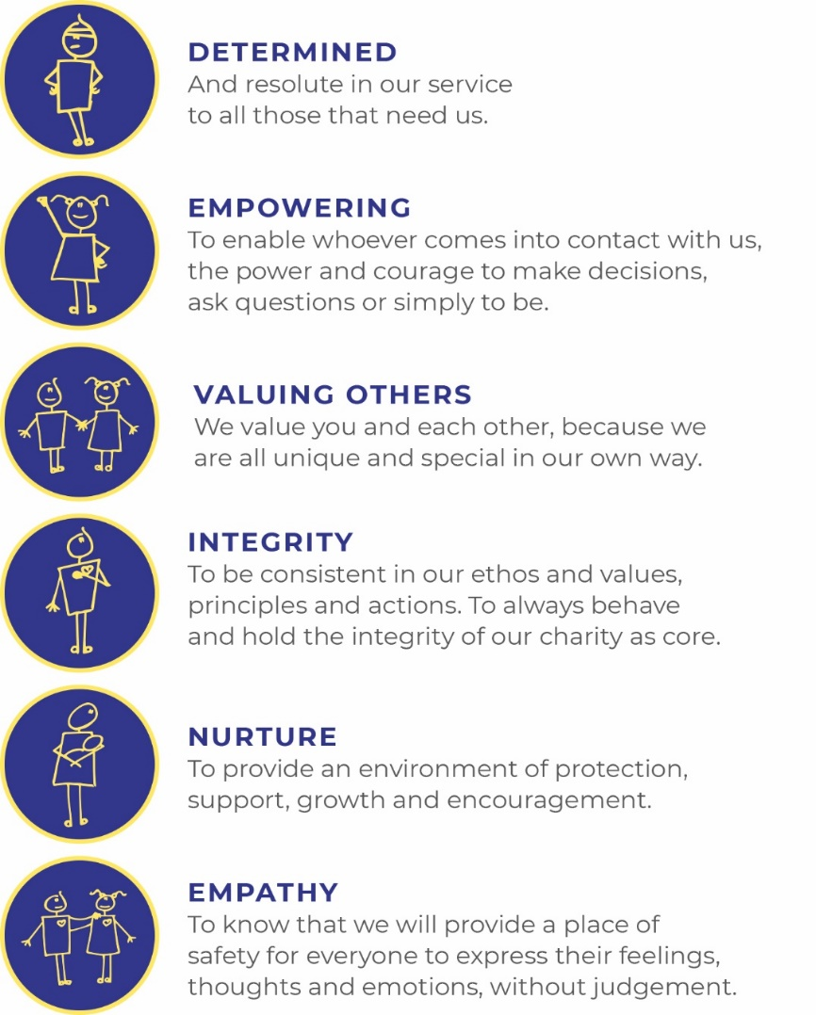
Our values
Our work is powered by our core values. They are key to everything that we do and the way in which we do it. Our expectation is that our values are upheld in all that we do and in our engagements, both internally and externally.

Our vision
We deliver palliative care to children and families through an holistic approach that meets the individual needs of each child and their family.

Our vision is to provide a service within Berkshire and surrounding counties that will give children and families a choice of care and support from a skilled and dedicated team. We work closely with the NHS, local authorities, and other services in delivering our care.

Our mission
Reaching out to every child and family who needs us, offering support and care from people who understand.

The role
Team Leader (Care)
Hours Full time (37.5 hours per week), part time may be considered, no less than 30 hours per week
Salary Band 7 (£47,680 - £55,009 per annum), pro rata for part time
Location Alexander Devine Children’s hospice in Maidenhead, Berkshire.
Benefits Competitive salary
Generous annual leave (plus your birthday as an additional day off)
Pension
Employee assistance programme
Death in Service Cover
Free on-site parking

Job purpose
To work as part of the Alexander’s Care Team providing clinical leadership to the team whilst maintaining ‘hands on care’. The team leaders, supported by the Matron, will be responsible for the clinical leadership of the community and in house service to ensure the quality and safe delivery of care provision. This role will complement a second Team Leader who will lead on managerial aspects of care
To assist and support effective governance processes, ensuring high quality standards of care and compliance with CQC standards.
To work as a senior member of the care team to provide excellent clinical leadership across the team as a whole. To deputise for senior colleagues where necessary.
To maintain own clinical knowledge, competence, and skills by working in clinical practice regularly.
Grade | Band 7
Managerial reporting responsibility | Matron
Professional reporting responsibility | Matron

Job Description
Areas of responsibility

Clinical:

- To demonstrate advanced knowledge, skills, and practice and ensure clinical standards are maintained and developed

- Works as an expert practitioner in palliative care acting as a resource for other healthcare professionals. Maintains a high profile in the clinical area, acting as a role model for good practice, working alongside the team as part of the 24/7 rota.
- To offer an holistic assessment, implement and evaluate individual care plans for children and young people considering their physical, social, psychological and spiritual needs.

- As a key link between the service and family, communicates complex, sensitive information effectively and empathetically, managing difficult situations and maintains the highest standards when communicating with children and families.
- Ensure effective communication and liaison with other members of the Hospice Team and outside agencies, reporting and discussing individual cases as appropriate.

- Checks and administers medication to children in line with ADCHS Medicines Management policy.

- Works flexibly to support emergency and end of life care

- Works with non-specialist interdisciplinary practitioners to complement their care, and the quality of the service provided.

- Actively participates in interdisciplinary meetings.

- Acts on clinical incidents pertinent to area, to reduce clinical risk.

- Is familiar with ADCHS safeguarding policy and report any concerns accordingly.

Managerial:

- Works collaboratively with the Alexander’s Care Team to develop and maintain a service model that meets the needs of children and families across the organisation.

- Provides professional clinical leadership to the team supporting service development, recruitment, appraisals and the delivery of an effective, safe and sustainable model of care delivery

- Maintains high standards in all areas of work and practice, supporting the development of evidence based care and quality in the organisation.

- Participates in all areas of clinical governance including, audit and risk management and uses data from audit / quality monitoring/ patient satisfaction questionnaires /service review to inform service improvement.

- Ensures patients are consulted in the development of services and utilises information to ensure that services are responsive to patient needs.

- Actively promotes diversity, in the delivery of services, in the development of staff and within the organisation. Supports and sustains relationships that promote dignity, rights and responsibilities. Identifies and takes action to address discrimination and oppression.

- Monitors and maintains the health, safety and security of self and any practitioners he/ she is responsible for in work area. Identifies and assesses risks in work activities and develops strategies to manage these effectively. Practices within risk management/ occupational health legislation and Organisational procedures.

- Working with the Senior Care Team ensures all policies, procedures and guidelines are implemented and adhered to.

- To ensure the safe provision of high-quality services at all times, this includes:-

- Managing staffing levels to ensure safe practice.
- To ensure that the skill mix is appropriate to provide a safe and effective service.
- Appropriately delegating the responsibility for the operational running of care
- Establish and develop effective communication structures to ensure the timely and effective cascade of information.
- To ensure all staff are aware of and act in line with legislation, regulation and organisational policies and procedures particularly safeguarding, medicines management and record keeping.
- To establish mechanisms to encourage feedback from all stakeholders, identifying areas for improvement and implementing agreed changes.
- Working with the Practice Educator, to identify, support and promote the learning and development needs of all clinical staff.
- To ensure compliance with mandatory training and the development of competence.
- To action an efficient and proper investigation of incidents and complaints and ensure the effective implementation of subsequent actions and learning.
- With others, develop and implement innovations and practice improvements.

- To take the lead in wider clinical projects as identified by the Director of Care.

- To cover for another Team Leader in their absence.

- To support the Director of Care with the appropriate management of recruitment, retention, induction, performance management, absence management and the development of all Care Team staff in line with all policies and regularity requirements.

Training, Supervision and Research:

- Develops own skills, taking responsibility for continuing professional development and performance, maintaining own portfolio in accordance with post registration requirements.

- Works to achieve competencies appropriate to grade and role. Identifies own development needs in relation to current practice and future plans, setting personal development objectives.

- To attend all statutory and mandatory training opportunities and keep up to date with current best practice.

- Working with the Practice Educator contributing to the planning and delivery of an education and competency programme

- To take responsibility for mentorship of staff and provide supervision to the Alexander Care Team

- Participate in clinical supervision for own development and support

- To deliver learning and development to other health and social care professional to enhance knowledge and skill

- Conducts/facilitates primary research/ contributes to research programmes. Promotes evidence-based practice in palliative and end of life care.

- Uses reflective practice, evaluation and research findings critically to contribute to the improvement of services.

General Requirements

- Is responsible for ensuring own practice complies with Data Protection, Confidentiality and Caldicott principles.

- Keep accurate and legible records supporting data collection

- Maintain confidentiality in all areas of work

- To be familiar with and adhere to all the Trusts Policies and procedures

- Promote safeguarding and welfare of children, young people and their families

- To adhere to fire and Health and safety regulations

- Represents Alexander Devine Children’s Hospice Service [ADCHS] at interagency meetings as requested.

- Demonstrates commitment to the values of ADCHS and the ethos of hospice care.

- Actively promotes Alexander Devine Children’s Hospice Service and supports the development of children’s palliative care across Berkshire

- Contributes to fundraising initiatives for the ADCHS.

The post holder must act at all times in a professional and responsible manner and have due regard to confidentiality and Health & Safety legislation.

This is an outline job description and should not be regarded as an inflexible specification. Responsibilities will be reviewed periodically in line with service priorities and duties may change or new duties be introduced after consultation with the post holder. As a term of your employment you may be required to undertake such other duties, and/or hours of work as may reasonably be required, commensurate with your general level of responsibility with the organisation.

Person specification
 | Essential | Desirable
Education, training, and qualifications | - RSCN or RN (Child) degree or diploma level  - Evidence of continual professional development and education | - Relevant specialist course eg palliative care and/or advanced communications  - Community qualification  - Teaching and assessing qualification
Experience | - Significant clinical and management experience.  - Experience of palliative care and symptom management  - Experience of needs assessment/care planning. Caseload management  - Experience of interagency working  - Experience working in community setting  - Experience of mentorship and leadership  - An understanding of clinical governance, risk and audit | - Experience caring for children with complex health needs  - Understanding of care provision in the community  - Caring for children at the end of life
Skills | - Demonstrates ability to place patient and family at centre of care.  - Excellent personal and communication skills.  - Excellent organisational ability  - Motivated and enthusiastic.  - Good facilitation/ presentation, teaching and assessing skills.  - Creative, resourceful and imaginative  - Excellent role model  - Ability to critically analyse research and evidence based practice  - Knowledge and understanding of safeguarding  - Familiarity of systems for quality control, clinical governance and clinical audit | - Writing of policy and procedures
 | Essential | Desirable
Other | - Car driver - vehicle available for working  - Flexible working hours contributing to 24/7 rota  - Commitment to the mission and ethos of Alexander Devine Children’s Hospice Service  - Able to work within and uphold our core values : determined, empowering, valuing others, integrity, nurture and empathy  - Ability to work alone and as a member of a team.  - Able to assess risk to maintain personal safety in a  - variety of settings  - Ability to cope with the physical demands expected of the role e.g. shift work, moving and handling, clinical and caring procedures  - Good IT skills  - Enhanced DBS  - Passed fit to undertake the duties of the post by Occupational Heal

A rewarding and special place to work
Finding ways to recognise, reward and support every member of our team is important to us. Here’s four big reasons why you will want to join our charity…

The amazing people that work here
Very simply, the team at Alexander Devine makes our charity such a unique place to work. To quote one of the young people that we support:
“If I had to summarise what makes Alexander Devine so special, I would say it’s the people that work there…they are like family to us”
Whichever part of the charity you are working or if you
are a volunteer, we are proud of our ‘one team’ spirit.

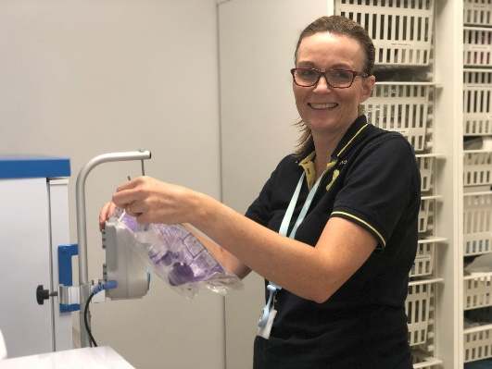
An employer that listens and cares
We pride ourselves on ensuring our staff receive regular supervision and support from their line manager, with opportunities for further training and development.
We also have an employee assistance programme, offering our employees a free confidential advisory and counselling service to help with any personal, work or family issues they may face.

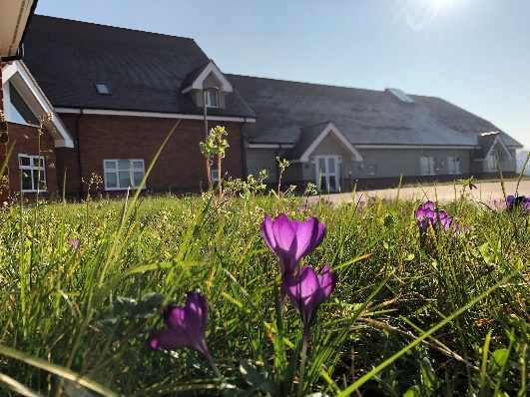
A beautiful setting in a convenient location
Our stunning purpose-built hospice is surrounded by beautiful countryside, but also just a stone’s throw from the M4 and A404, on the outskirts of Maidenhead.
There is free on-site parking for all staff.

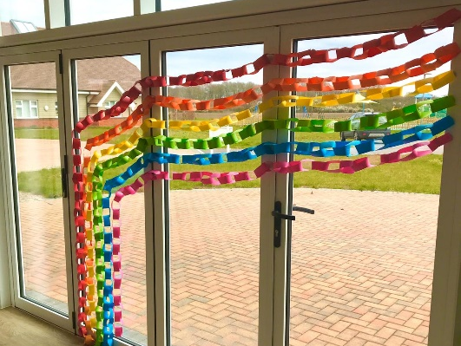
A strong focus on work / life balance, taking care of your health and planning for retirement
Making sure our employees have a good work/life balance is vital. In addition to a wellbeing programme, we offer generous annual leave entitlement with a day off for your birthday and an extra two additional days holiday, known as Alexander days each year.
There are also staff discounts on a range of products and services including travel and high street savings.
Further information

Equal opportunities
It is the policy of Alexander Devine Children’s Hospice Service to provide equal opportunities to any employee or job applicant and will not discriminate either directly or indirectly because of race, sex, sexual orientation, transgender status, religion, or belief, marital or civil partnership status, age, disability, or pregnancy and maternity.

Safeguarding statement
We are committed to safeguarding and promoting the welfare of children and applicants must be willing to undergo Child Protection screening appropriate to the post, including an Enhanced DBS check.

How to apply
For an informal discussion about the role, please call Julie Hughes on 01628 822777 or email questions to julieh@alexanderdevine.org
For an application form, please email fayd@alexanderdvine.org
CVs will not be accepted without the completion of our application form
Completed applications must be returned to fayd@alexanderdevine.org, by midday on Monday 30th March 2026.

