








Reaching out to every child
and family that needs us

www.alexanderdevine.org

Application Pack

Alexander’s Nurse
Band 5
RN(Child) or RN(LD)

Closing date – 11 May 2026

Alexander Devine Children’s Hospice Service

Alexander Devine Children’s Hospice Service (Alexander Devine) is a local charity that provides specialist care and vital support to babies, children and young people with life-limiting and life-threatening conditions, and their families, across Berkshire and into surrounding counties.

We individualise our approach to meet the unique clinical, emotional and practical needs of each child and their family, ensuring they receive the best possible care and support. Our comprehensive range of care services include Respite care, Specialist play, Symptom management, Family support, End of life care and Bereavement support. We provide care from our children’s hospice in Maidenhead as well as in the family home and across the community, including hospitals and schools.

Our hospice facilities offer opportunities for children and their siblings to experience fun, joy and adventures, and help families make precious memories for as long as they have. These include a hydrotherapy pool, sensory room, music room, games room, outdoor playground and sensory garden, six children’s bedrooms and two self-contained family flats. We also have a dedicated bereavement suite with its own garden.

Our children’s hospice service is free of charge for families, but it costs over £2.8 million a year just to maintain our current level of care. With very minimal government funding, our charity is almost entirely reliant on donations, fundraising and gifts in Wills to meet the costs of running our service. Which means every penny donated makes a huge difference to those we support.

We currently support over 165 children and their families, but we are committed to growing our service and reaching out to every child and family that needs us. In Berkshire alone, we know that there are an estimated 1,371 children with life-limiting conditions. And research shows that this number is likely to increase by at least a further 11% by 2030.

The charity was founded by John and Fiona Devine in memory of their son Alexander who sadly passed away from a rare brain tumour in 2006 at the age of eight. Their personal experience led them to realise a desperate need for a local children’s hospice service with a hospice facility in Berkshire.

www.alexanderdevine.org
Reg. Charity No. 1118947
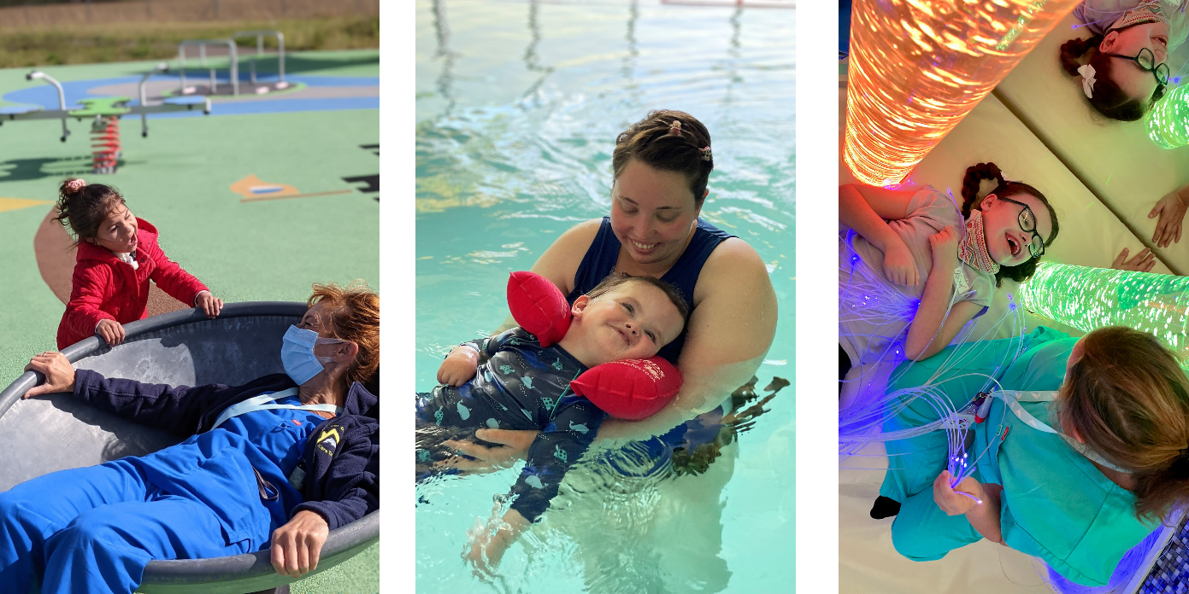

Our core values
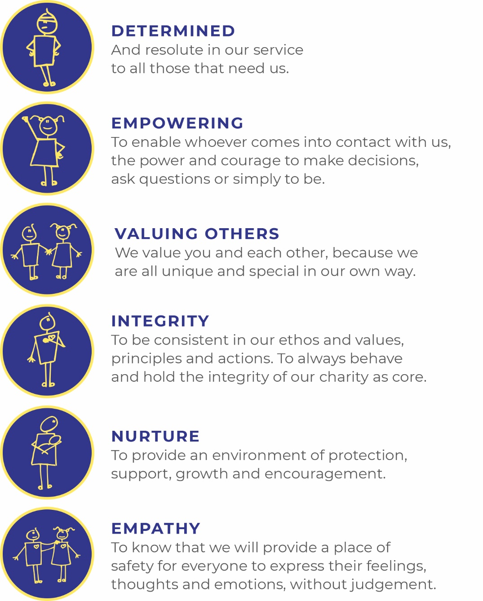

Job Description

Job Title: | Alexander’s Nurse – Children’s Palliative Care Community Nurse
Grade: | Band 5  £31,254 to £38,272 per annum (or rata for part time)  37.5 hours per week, or part time may be considered.
Managerial Reporting Responsibility: | Director of Care, Alexander Devine Children’s Hospice Service
Professional Reporting Responsibility: | Director of Care, Alexander Devine Children’s Hospice Service
Job Purpose: | Working as part of the Alexander’s Care Team this post is to provide holistic care and support to children with a life threatening and life limiting condition and their families across the geographical area supported by Alexander Devine Children’s Hospice Service.  The post will involve a flexible, needs led approach to care delivery, contributing to a 24/7 rota by the Alexander’s Care Team. The post holder will support the care of children and young people providing palliative and end of life care in the child’s home or other community setting and in the hospice, working both autonomously and in collaboration with other agencies.

Core Responsibilities

Managerial:

- Works collaboratively with the Alexander’s Care Team to meet the needs of children, young people and their families.

- Works both as an independent practitioner, and as an effective member of the wider interdisciplinary clinical team.

- Maintains quality in own work and encourage others to do so.

- Works in a way that complies with and maintains all areas of safety and risk.

- Ensures patients are consulted in the development of services and utilises information to ensure that services are responsive to patient needs.

- Is responsible for ensuring own clinical practice complies with Data Protection, Confidentiality and Caldicott principles.

- Actively promotes equality and diversity, in the delivery of services. Supports and sustains relationships that promote dignity, rights and responsibilities. Identifies and takes action to address discrimination and oppression.

- Monitors and maintains the health, safety and security of self and any practitioners he/ she is responsible for in work area. Looks for potential risks and takes appropriate action to manage potential problems and emergencies.

- Develops own skills, taking responsibility for continuing professional development and performance, maintaining own portfolio in accordance with post registration requirements. Works to achieve competencies appropriate to grade and role. Identifies own development needs in relation to current practice and future plans, setting personal development objectives.

- Demonstrates commitment to the values of ADCHS and the ethos of hospice care.

- Actively promotes Alexander Devine Children’s Hospice Service and supports the development of children’s palliative care across Berkshire

- Contributes to fundraising initiatives for the ADCHS.

Clinical:

- Holds own defined caseload.

- Communicates complex, sensitive information effectively and empathetically to patients and relatives and maintains the highest standards when communicating with children, families and the wider public.

- Completes and maintains up to date records in line with principles of best practice.

- Actively supports assessment, delivery of care and review, managing all elements of high quality care planning.

- Supports care understanding the wider care package working with other agencies.

- Supports families throughout the care pathway including initial diagnosis and discharge planning form hospital to community.

- Works flexibly to support appropriate intervention where there may be escalation of symptoms or family difficulties.

- Checks and administers medication to children in their own home in line with ADCHS Administration of Medicines policy.

- Works flexibly to support 24/7 rotas, emergency and end of life care.

- Works effectively with all members of the multi-disciplinary team.

- Acts on clinical incidents pertinent to area, to reduce clinical risk.

- Is familiar with ADCHS safeguarding policy and report any concerns accordingly.

Teaching, Training and Research:

- Provides informal support to children, young people and families as required.

- Promotes evidence based practice in palliative and end of life care.

- Uses reflective practice, evaluation and research findings critically to contribute to the improvement of services.

- Links with other practitioners in specialist area in order to share/ learn from examples of good practice.

- Develops/ contributes to all appropriate areas of data collection.

This job description reflects the present requirements of the post. As duties and responsibilities change and develop, the job description will be reviewed and is subject to amendment in consultation with the post holder

Personal Specification
Alexander’s Nurse – Children’s Palliative Care Community Nurse – Band 5

 | Essential | Desirable
Education/ Qualifications/ Training: | - RGN or RSCN or RN (Child) or RN (Learning Disability) at degree or diploma level  - Evidence of continual professional development and education | - Relevant course in palliative or end of life care  - Community qualification
Experience: | - 1 years post registration experience.  - Experience of needs assessment/care planning  - Experience of Caseload management  - Experience of caring for children and families with complex needs | - Experience working in community setting  - Caring for children at the end of life
Skills | - Demonstrates ability to place the child and family at centre of care.  - Excellent personal and communication skills.  - Excellent organisational ability.  - Motivated and enthusiastic.  - Creative, resourceful and imaginative  - Excellent role model  - Ability to critically analyse research and evidence based practice  - Knowledge and understanding of safeguarding  - Familiarity of systems for quality control, clinical governance and clinical audit
Other | - Car driver - vehicle available for working  - Flexible working hours contributing to 24/7 rotas  - Commitment to the mission and ethos of Alexander Devine Children’s Hospice Service  - Able to work within and uphold our core values : determined, empowering, valuing others, integrity, nurture and empathy  - Ability to work alone and as a member of a team.  - Able to assess risk to maintain personal safety in a  variety of settings  - Ability to cope with the physical demands expected of the role e.g. shift work, moving and handling, clinical and caring procedures  - Good IT skills  - Enhanced DBS  - Passed fit to undertake the duties of the post by Occupational Health

A rewarding and special place to work
Finding ways to recognise, reward and support every member of our team is important to us. Here’s four big reasons why you will want to join our charity…
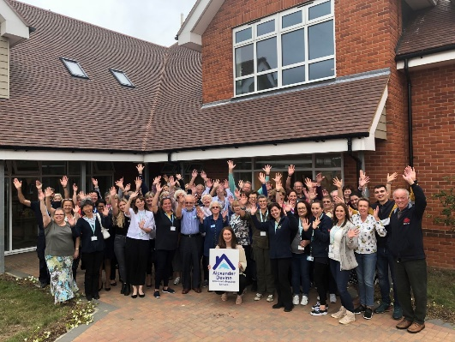
The amazing people that work here
Very simply, the team at Alexander Devine makes our charity such a unique place to work. To quote one of the young people that we support:
“If I had to summarise what makes Alexander Devine so special, I would say it’s the people that work there…they are like family to us”
Whichever part of the charity you are working or if you
are a volunteer, we are proud of our ‘one team’ spirit.

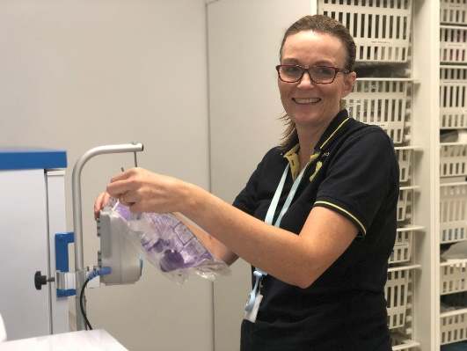
An employer that listens and cares
We pride ourselves on ensuring our staff receive regular supervision and support from their line manager, with opportunities for further training and development.
We also have an employee assistance programme, offering our employees a free confidential advisory and counselling service to help with any personal, work or family issues they may face.

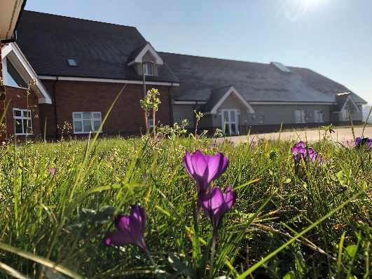
A beautiful setting in a convenient location
Our stunning purpose-built hospice is surrounded by beautiful countryside, but also just a stones throw from the M4 and A404, on the outskirts of Maidenhead.
There is free on-site parking for all staff.

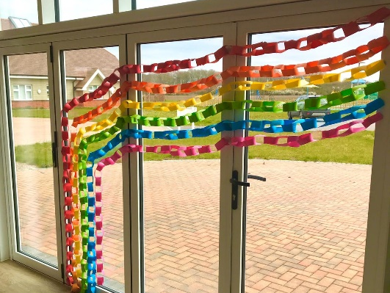
A strong focus on work / life balance, taking care of your health and planning for retirement
Making sure our employees have a good work/life balance is vital. In addition to a wellbeing programme, we offer generous annual leave entitlement with a day off for your birthday and an extra two additional days holiday, known as Alexander days each year.
There are also staff discounts on a range of products and services including travel and high street savings.
Further information

Equal opportunities
It is the policy of Alexander Devine Children’s Hospice Service to provide equal opportunities to any employee or job applicant and will not discriminate either directly or indirectly because of race, sex, sexual orientation, transgender status, religion, or belief, marital or civil partnership status, age, disability, or pregnancy and maternity.

We are committed to building a workforce that reflects the diverse communities we serve. At present, we recognise that our staff group is not as diverse as we would like it to be. We warmly welcome applications from individuals from underrepresented and minority groups, whose perspectives and experiences will help strengthen our team and the care we provide. We are dedicated to creating an inclusive environment where everyone feels valued, respected, and able to thrive

Safeguarding statement
At Alexander Devine Children’s Hospice, the safety and wellbeing of the children and families we support is our highest priority. We are committed to safer recruitment practices to ensure that everyone who works or volunteers with us is suitable to do so.

All appointments are made following robust recruitment processes which include appropriate references, identity checks, verification of qualifications and employment history if necessary, and relevant safeguarding checks, including an enhanced Disclosure and Barring Service (DBS) check where required. It is a criminal offence for people who are barred from working in regulated activity (under the Safeguarding and Vulnerable Groups Act 2006) to apply for roles that require them to work unsupervised with that particular group
Our recruitment and selection processes are designed to promote the welfare of children and young people and to deter, identify and reject anyone who may pose a risk to them.
Applications
To apply, please email fayd@alexanderdevine.org to request an application form.
Once complete, please post to:
Fay Denwood
Alexander Devine Children’s Hospice Service
Snowball Hill
SL6 3LU

Alternatively, completed forms can be emailed to fayd@alexanderdevine.org
Applications must be received by midday on 11th May 2026

