



Application Pack
Fundraising Administrator
Closing date for applications: Monday 18th May 2026
Alexander Devine Children’s Hospice Service

Alexander Devine Children’s Hospice Service (Alexander Devine) is a local charity that provides specialist care and vital support to babies, children and young people with life-limiting and life-threatening conditions, and their families, across Berkshire and into surrounding counties.

We individualise our approach to meet the unique clinical, emotional and practical needs of each child and their family, ensuring they receive the best possible care and support. Our comprehensive range of care services include Respite care, Specialist play, Symptom management, Family support, End of life care and Bereavement support. We provide care from our children’s hospice in Maidenhead as well as in the family home and across the community, including hospitals and schools.

Our hospice facilities offer opportunities for children and their siblings to experience fun, joy and adventures, and help families make precious memories for as long as they have. These include a hydrotherapy pool, sensory room, music room, games room, outdoor playground and sensory garden, six children’s bedrooms and two self-contained family flats. We also have a dedicated bereavement suite with its own garden.

Our children’s hospice service is free of charge for families, but it costs over £2.8 million a year just to maintain our current level of care. With very minimal government funding, our charity is almost entirely reliant on donations, fundraising and gifts in Wills to meet the costs of running our service. Which means every penny donated makes a huge difference to those we support.

We currently support over 165 children and their families, but we are committed to growing our service and reaching out to every child and family that needs us. In Berkshire alone, we know that there are an estimated 1,371 children with life-limiting conditions. And research shows that this number is likely to increase by at least a further 11% by 2030.

The charity was founded by John and Fiona Devine in memory of their son Alexander who sadly passed away from a rare brain tumour in 2006 at the age of eight. Their personal experience led them to realise a desperate need for a local children’s hospice service with a hospice facility in Berkshire.

www.alexanderdevine.org
Reg. Charity No. 1118947


Our values, vision and mission

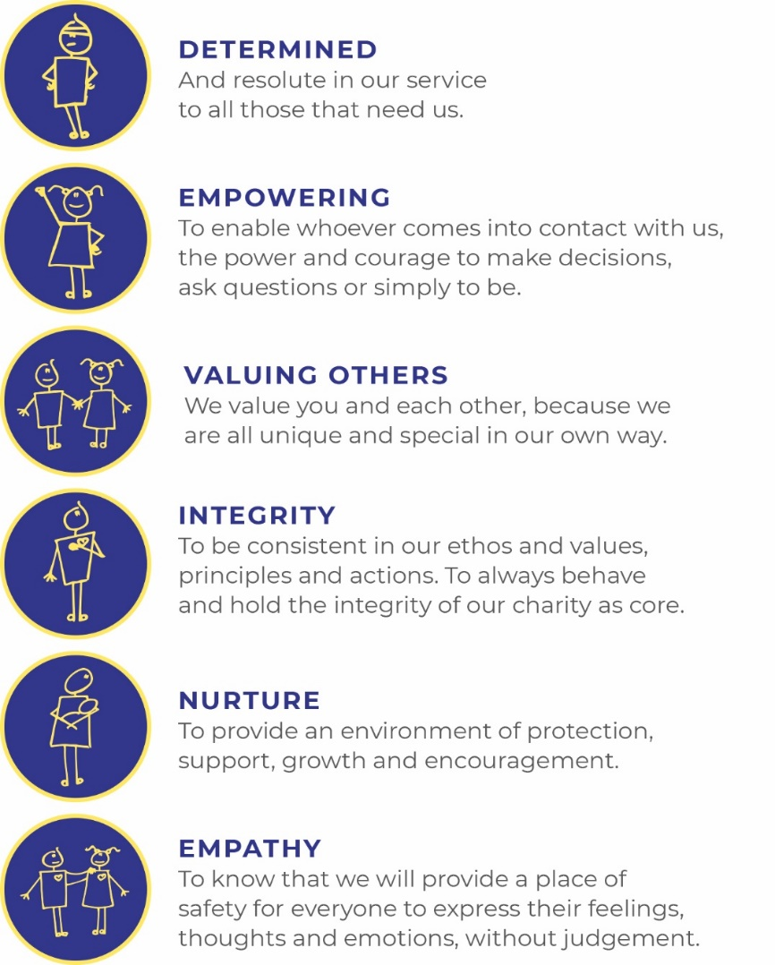
Our values
Our work is powered by our core values. They are key to everything that we do and the way in which we do it. Our expectation is that our values are upheld in all that we do and in our engagements, both internally and externally.

Our vision
We deliver palliative care to children and families through an holistic approach that meets the individual needs of each child and their family.

Our vision is to provide a service within Berkshire and surrounding counties that will give children and families a choice of care and support from a skilled and dedicated team. We work closely with the NHS, local authorities and other services in delivering our care.

Our mission
Reaching out to every child and family who needs us, offering support and care from people who understand.

The role
Fundraising Administrator
Hours Part time – 30 hours per week over 5 days
Salary Band 4 FTE: £21,672 - £24,120 per annum (£27,091 - £30,150 pro-rata)
Location Alexander Devine Children’s hospice in Maidenhead, Berkshire.
Benefits Competitive salary
Generous annual leave (plus your birthday as an additional day off)
Pension
Employee assistance programme
Death in Service Cover
Private Medical Insurance
Free on-site parking

Job purpose
The post holder will be the first point of contact for supporters in person, by email or phone and part of their journey with us, thanking them and ensuring they feel appreciated and valued. You will also be responsible for managing a busy office and supporting the administrative needs of the fundraising team.
In this role, no two days are ever the same! This role would suit someone who thrives multitasking in a busy environment, enjoys a mix of building relationships including over the phone and has the focus and attention to detail to excel with the administrative parts of the role.

Grade | Fundraising Administrator - Band 4
Managerial reporting responsibility | Director of Fundraising, Alexander Devine Children’s Hospice Service
Professional reporting responsibility | Director of Fundraising, Alexander Devine Children’s Hospice Service

Job Description
Areas of responsibility

Supporter Relations: To provide excellent customer care to our supporters including:

- To be the first point of contact for supporters face to face, by email and by phone demonstrating excellent customer service, ensuring their needs are met and they have a positive interaction with Alexander Devine.
- Creating and sending thank you letters to supporters according to our stewardship protocol and timescales.
- Making calls to supporters to thank and support them.
- Being curious with our supporters to develop our relationship with them and give them further opportunities to be involved in supporting our work

Office Management and Administration: Fundraising Team support including:
- To be responsible for office processes, ensuing an efficient working environment for the fundraising team.
- To organise administrative support by office volunteers and supervise volunteers in their day-to-day tasks.
- To look after visitors to the hospice, arranging refreshments and supporting meetings and interviews.
- To ensure that all stocks of stationery, resources and equipment are tracked, stored and maintained well.
- To support internal and external fundraising meetings, preparing agendas and minutes as requested.
- To manage the ordering, stock control, sale and reconciliation of Christmas cards and merchandise and other online retail through the year.
- Supporting our events and projects with fundraising administration, for example guest list management.
- Supporting the Database Administrator to ensure that the charity’s database (Salesforce) is kept fully up-to-date and compliant with data protection regulations.
- To produce fundraising reports as required.
- Identify and explore opportunities to use technology to increase efficiency and effectiveness within the team.
- Take on ad hoc projects in support of the team.
General
- Manage own workload in a cost effective and proactive way.
- To ensure that sensitive information is correctly maintained in all forms.
- To maintain accurate systems, records, data and processes in line with GDPR, the Fundraising Regulator, Charities Commission and Care Quality Commission.
- As and when required, to work flexibly to support the team and wider charity.
- Stay up-to-date with best practices and regulatory requirements, ensuring compliance with relevant laws and guidelines.

Duties in common with other members of staff
- Contribute positively to good teamwork.
- To report and record accidents and incidents.
- To be an ambassador for the charity.
- To maintain the best appearance of your immediate working area.
- To demonstrate a positive and supportive attitude to staff and volunteers.
- Respect confidentiality applying to all areas of the hospice.
- To adhere to the Infection Control Policies and Procedures set by the charity and the Care Quality Commission.
- A commitment to, attitude and behaviour that reflects our core values - Determined, Empowering, Valuing others. Integrity, Nurture, Empathy.
- Commitment to ensuring your own wellbeing and that of your colleagues.

This job description reflects the present requirements of the post. As duties and responsibilities change and develop, the job description will be reviewed and is subject to amendment in consultation with the post holder.

Person specification
 | Essential | Desirable
Education, training and qualifications | English Language and Mathematics GCSE or equivalent grade C (grade 4) or above
Experience | Demonstrable experience of working in a customer focused environment and of building relationships with people  Experience of administration in an office environment | Basic Event Management experience  Database Experience, particularly Salesforce  Project management experience  Experience of working in a fundraising context and of fundraising  processes and tools  Experience managing volunteers
Skills | Excellent interpersonal and communication skills and ability to develop relationships internally with colleagues and externally with supporters of the organisation  Excellent proficiency and confidence in Microsoft Office including Word, Excel, Outlook and Canva.  Excellent written and oral communication skills – ability to craft excellent supporter communications  Excellent attention to detail and accuracy.  A proactive and intelligent approach to problem solving and improving administrative processes  Organised – able to juggle responsibilities prioritise effectively and work well under own initiative with minimum supervision | Basic skills in Canva or an equivalent design package  Confidence using technology including AI to increase efficiency and effectiveness
 | Essential | Desirable
Other | Car driver - vehicle available for working  Ability to work flexible working hours  Commitment to the mission and ethos of Alexander Devine Children’s Hospice Service  Able to work within and uphold our core values: determined, empowering, valuing others, integrity, nurture and empathy  Ability to work alone and as a member of a team  Able to assess risk to maintain personal safety in a variety of settings  Ability to cope with the physical demands expected of the role  Ability to maintain and respect confidentiality  Willing to undertake an Enhanced DBS  Passed fit to undertake the duties of the post by Occupational Health

A rewarding and special place to work
Finding ways to recognise, reward and support every member of our team is important to us. Here’s four big reasons why you will want to join our charity…
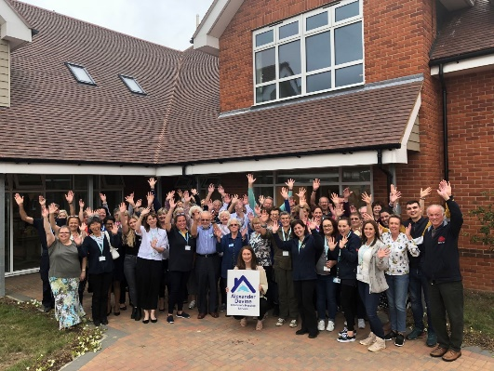
The amazing people that work here
Very simply, the team at Alexander Devine makes our charity such a unique place to work. To quote one of the young people that we support:
“If I had to summarise what makes Alexander Devine so special, I would say it’s the people that work there…they are like family to us”
Whichever part of the charity you are working or if you
are a volunteer, we are proud of our ‘one team’ spirit.

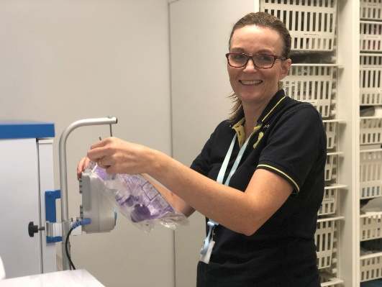
An employer that listens and cares
We pride ourselves on ensuring our staff receive regular supervision and support from their line manager, with opportunities for further training and development.
We also have an employee assistance programme, offering our employees a free confidential advisory and counselling service to help with any personal, work or family issues they may face.

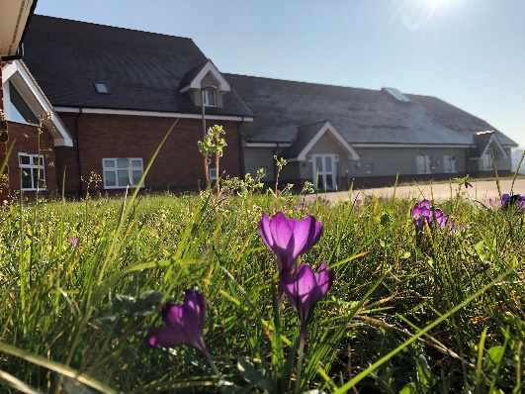
A beautiful setting in a convenient location
Our stunning purpose-built hospice is surrounded by beautiful countryside, but also just a stones throw from the M4 and A404, on the outskirts of Maidenhead.
There is free on-site parking for all staff.

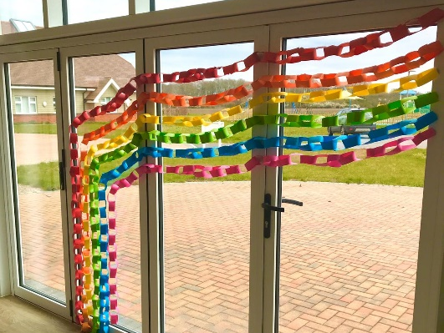
A strong focus on work / life balance, taking care of your health and planning for retirement
Making sure our employees have a good work/life balance is vital. In addition to a wellbeing programme, we offer generous annual leave entitlement with a day off for your birthday and an extra two additional days holiday, known as Alexander days each year.
There are also staff discounts on a range of products and services including travel and high street savings.
Further information

Equal opportunities
It is the policy of Alexander Devine Children’s Hospice Service to provide equal opportunities to any employee or job applicant and will not discriminate either directly or indirectly because of race, sex, sexual orientation, transgender status, religion, or belief, marital or civil partnership status, age, disability, or pregnancy and maternity.

We are committed to building a workforce that reflects the diverse communities we serve. At present, we recognise that our staff group is not as diverse as we would like it to be. We warmly welcome applications from individuals from underrepresented and minority groups, whose perspectives and experiences will help strengthen our team and the care we provide. We are dedicated to creating an inclusive environment where everyone feels valued, respected, and able to thrive

Safeguarding statement
At Alexander Devine Children’s Hospice, the safety and wellbeing of the children and families we support is our highest priority. We are committed to safer recruitment practices to ensure that everyone who works or volunteers with us is suitable to do so.

All appointments are made following robust recruitment processes which include appropriate references, identity checks, verification of qualifications and employment history if necessary, and relevant safeguarding checks, including an enhanced Disclosure and Barring Service (DBS) check where required. It is a criminal offence for people who are barred from working in regulated activity (under the Safeguarding and Vulnerable Groups Act 2006) to apply for roles that require them to work unsupervised with that particular group
Our recruitment and selection processes are designed to promote the welfare of children and young people and to deter, identify and reject anyone who may pose a risk to them.

How to apply
For an informal discussion about the role, please call Jenni Green, Lead for Trusts and Supporter Engagement on 01628 822777 or email questions to jennig@alexanderdevine.org
For an application form, please email fayd@alexanderdevine.org
Completed applications must be returned to fayd@alexanderdevine.org, by midday on Monday 18th May

