



Application Pack

Counsellor
Closing Date – 16th November 2026

Alexander Devine Children’s Hospice Service

We are a charity that provides specialist care and vital support to children with life-limiting and life-threatening conditions and their families across Berkshire and the surrounding counties.

John and Fiona Devine from Windsor set up the charity in memory of their extraordinary little boy who sadly passed away in 2006 at the age of eight from a rare brain tumour. Their personal experience, and subsequent extensive research, led them to realise that there was a vital need for a local children’s hospice service and hospice.

Our children’s hospice service means very different things for each child and their family and as such, our care is very individual. Whatever and wherever the need, we are dedicated to bringing comfort and care to these families. Our services include: respite care, specialist play, symptom management, family support, end of life care and bereavement support.

Care is delivered either at home, in hospital, in schools or within our very own children’s hospice, which was opened summer 2018. Designed to complement the community service, the hospice has state-of-the-art facilities such as a hydrotherapy pool, sensory room, music room, games room, family accommodation and bereavement suite.

We currently support over 130 children and their families, but we are committed to growing our service and reaching out to every child and their family that needs us. In Berkshire alone we know that there are over 1,370 children with life-limiting conditions.

96% of what we need to deliver our children’s hospice service comes from voluntary donations and every penny that is raised makes a real difference to local families.

www.alexanderdevine.org
Reg. Charity No. 1118947

Our core values
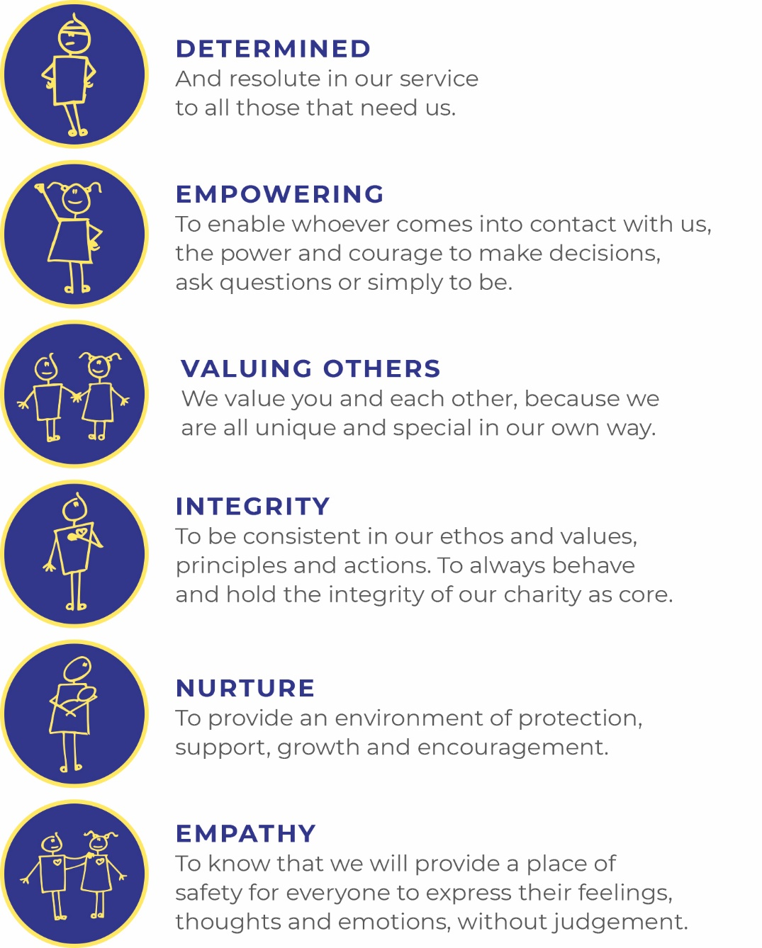

Job Description

Job Title: | Counsellor – 15 hours per week
Grade: | Band 6 - £13,750 - £16,802 per annum  (£39,059 to £47,730 pro rata)
Accountable to: | Family Support Lead
Job Purpose: | Working as part of the family Support Team the post holder will be responsible for delivering counselling and support services as appropriate and based on need from the point of referral to the service to end-of-life care and bereavement  To provide counselling and support according to the families individual needs and where appropriate in partnership with other professionals and agencies.  To work collaboratively with other teams to support the needs of families.

Key Responsibilities
- To support families through referral process in conjunction with the care team ensuring that the families’ individual needs are met, including cultural, ethnic and spiritual needs.

- To facilitate the assessment of children and families, newly referred, for suitability of accessing the family support and counselling service.

- To determine the families’ individual needs and identify appropriate available services.

- To offer face to face therapeutic support – using a range of counselling approaches.

- To ensure that children, young people and their parents are empowered through information and understanding of their rights and options to access services required.

- To provide signposting to enable families to access the information and practical support required.

- To facilitate the provision of ongoing emotional support to families in conjunction with the care team, to ensure available support is appropriate and timely.

- To support the child/young person and their family before and following death.

- To liaise with other professionals/agencies involved with a family to ensure continuity of care.

- To assist with the audit of the service and ensure evidence based practise.

- To support planning and running of family support led events and activities in addition to those organised by the hospice

- To adhere to your professional body (BACP) code of ethics.

Management
- To contribute to effective communication within the hospice including appropriate and accurate documentation

- To represent the hospice at external meetings to make links with related agencies including media publicity where appropriate.

- To attend all required in-house meetings and MDT meetings.

- To support the development of the family support team programme.

Training and Development
- To attend regular supervision, individual and group sessions

- To attend staff development programmes, training courses, conferences and study days as deemed necessary.

- To maintain own professional portfolio and keeping updated with developments and research based practice within given field of expertise and sharing knowledge.

- To offer input to training programmes as appropriate.

General Responsibilities
- To adhere to and comply with organisational policies, procedures and guidelines at all times.

- Implement Risk Management strategies (including reporting, registering risk and learning) - taking all reasonable steps to manage and promote a safe and healthy working environment which is free from discrimination.

- Comply with the organisational policy on confidentiality, information governance and the Data Protection Act as amended relating to information held manually or on computerised systems.

- Respect the confidentiality of children, young adults and staff and volunteers at all times.

- Promote and protect the privacy and dignity of children and young adults at all times.

- Comply with the requirements of the organisational Safeguarding Policy, and at all times during the course of employment act in such a way as to promote the wellbeing of children and other vulnerable people.

- Ensure compliance with Care Quality Commission (CQC), and The Health & Social Care Act 2008 (Regulated Activities).

- Implement and maintain Health and Safety regulations – through risk assessment. Maintain a constant awareness of health, welfare and safety issues affecting colleagues, service users, volunteers, visitors and themselves, reporting any accidents or faults in line with organisational policy, and fully participating in health and safety training.

- Maintain high standards of infection prevention and control practice throughout the performance of duties and in accordance with the organisations Infection Prevention and Control Policies and Procedures.

- Embrace the volunteer culture, which exists in the organisation.

- To work collaboratively with the fundraising team to support funding opportunities for the organisation.

- Demonstrate commitment to the values of Alexander Devine Children’s Hospice Service.

- Actively promote Alexander Devine Children’s Hospice Service and supports the development of children’s palliative care across Berkshire and the ethos of Hospice Care.

The post holder must act at all times in a professional and responsible manner and have due regard to confidentiality and Health & Safety legislation.
This is an outline job description and should not be regarded as an inflexible specification. Responsibilities will be reviewed periodically in line with service priorities and duties may change or new duties be introduced after consultation with the post holder. As a term of your employment you may be required to undertake such other duties, and/or hours of work as may reasonably be required, commensurate with your general level of responsibility with the organisation.



PERSON SPECIFICATION
Family Support Worker
Criteria | Essential | Desirable
Qualifications | - Diploma/qualification in Counselling | - Specialist training in loss and bereavement  - Experience of working with children with complex needs and palliative care
Experience | - Experience of working with bereaved clients  - Experience of working with the whole family  - Experience of managing individual and group sessions  - Experience of working in a health care setting | - Knowledge of grief and loss  - Understanding of hospice services  - Minimum of 2 years working with children and families
Skills and abilities | - Ability to assess the needs of families  - Ability to organise and plan activities and events  - Demonstrate ability to place patient and family at centre of care.  - Excellent interpersonal skills and the ability to communicate effectively orally and in writing.  - Evidence of advanced communication skills including proven ability in conflict management.  - Good organisational and administration skills, including IT skills. | - Ability to critically analyse research and evidence based practice  - Teaching and presentation skills.
Knowledge / Understanding | - Evidence of continual professional development and education  - Professional accountability issues and scope of professional practice  - Up to date knowledge of safeguarding issues.  - Health needs in a racially and culturally diverse population | - High level knowledge of safeguarding
Personal attributes / abilities | - Enthusiastic and highly self-motivated person.  - A team player with the ability to use own initiative  - A commitment to the mission and ethos of Alexander Devine Children’s Hospice Service  - Able to work within and uphold our core values : determined, empowering, valuing others, integrity, nurture and empathy  - A commitment to promoting equality of opportunity.  - A commitment to ongoing personal and professional development.
Other | - Flexible approach to working hours  - Current, full driving licence  - Not on ISA Barred list from working with children/adults  - Good attendance record  - Ability to work alone and as a member of a team.  - Able to assess risk to maintain personal safety in a variety of settings  - Ability to cope with the physical demands expected of the role e.g. flexible hours  - Good IT skills  - Enhanced DBS  - Passed fit to undertake the duties of the post by Occupational Health

Further information

Equal opportunities
It is the policy of Alexander Devine Children’s Hospice Service to provide equal opportunities to any employee or job applicant and will not discriminate either directly or indirectly because of race, sex, sexual orientation, transgender status, religion or belief, marital or civil partnership status, age, disability, or pregnancy and maternity.

Safeguarding statement
We are committed to safeguarding and promoting the welfare of children and applicants must be willing to undergo Child Protection screening appropriate to the post, including checks with the Disclosure and Barring Service.

Applications
To apply, please email fayd@alexanderdevine.org to request an application form.
Once complete, please post to:
Fay Denwood
Alexander Devine Children’s Hospice Service
Snowball Hill
SL6 3LU

Alternatively, completed forms can be emailed to fayd@alexanderdevine.org
Closing Date – 16th November 2026

